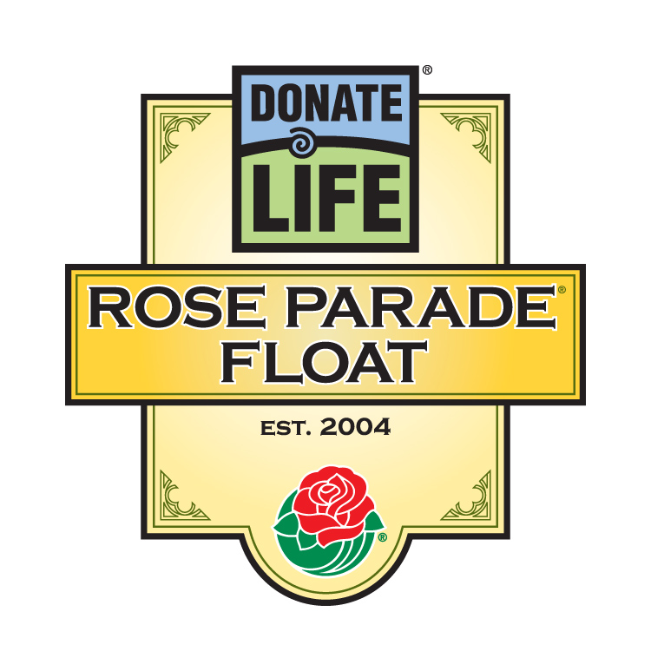

For Immediate Release

Contacts: Bryan Stewart, (213) 401-1226 or bstewart@onelegacy.org
Rivian Bell or Lisa Bernfeld, (213) 612-4927, (888) 477-4319 (24/7), rbell@jdipr.com, lbernfeld@jdipr.com

EIGHT ORGAN AND TISSUE DONOR FAMILY MEMBERS show the ties that bind by walking ALONGSIDE THE DONATE LIFE rose parade® FLOAT

Balloon Tether Lines to Connect Walkers to ‘Floragraph’ Portraits of Their Loved Ones,
Including Ransom Tipton, Honored on ABC’s ‘Extreme Makeover: Home Edition’

LOS ANGELES, Calif. – Oct. 1, 2007 – Donate Life will bring an emotional new element to its fifth Rose Parade float entry, Life Takes Flight, in the 2008 Rose Parade. Not only will 24 people who received transplants ride the float, but eight family members of those who donated organs, eyes, and tissue will walk alongside the float as a visual reminder of the pride donor families feel about their loved ones’ gifts of life.

The eight family members include Missy Tipton of Waleska, Ga., the 17-year-old sister of Ransom Tipton, who was only 16 when he died in a car crash three months after his family’s home was destroyed in a fire. The Tipton-Smith family was featured on ABC’s “Extreme Makeover: Home Edition” last March, and the episode’s focus on Ransom’s donation of life-saving organs resulted in a nationwide surge of donor designations, with tens of thousands of people signing up with state organ and tissue donor registries.

Missy will be joined in the five-mile walk by Josie Flores, Miami, Fla.; Jeannie McGuire, Portland, Ore.; Terry Murray, Silver Spring, Md.; Mike Moore, Baton Rouge, La.; Eva Perez, Los Angeles; Arthur Stone, Greeley, Colo.; and Laurie Wolowic, Studio City, Calif. All eight family members will hold tether lines connecting each to a “floragraph” – an artistic portrait created with floral materials – of their loved one adorning a hot air balloon.

The 2008 Donate Life Rose Parade float features a balloon festival, with four colorful hot air balloons rising 30 feet high above 24 riders whose lives have been saved and renewed by organ, eye, tissue and blood donors.

“We are grateful that the Tournament of Roses encouraged us to present not only riders whose lives have taken flight because they received life-saving transplants, but also walkers celebrating the memory of their loved ones, whose gifts of life make such a difference for people, families and communities,” said Bryan Stewart, chairman of the float organizing committee and director of communications for OneLegacy, the non-profit, federally designated organ and tissue recovery agency serving the greater Los Angeles area. “Their stories are unique and inspiring, and we are privileged to connect family members with their loved ones in such a meaningful way.”
- MORE -
DONATE LIFE FLOAT – 2-2-2

Among the walkers is Mike Moore, who donated his daughter Katie’s organs upon her death at age 17. Ten months later, he would donate his wife Melanie’s organs and tissue. Together, six people are alive today because of the Moore family’s gifts of life.

Jeannie McGuire and Eva Perez have never met, but they share the heartache of losing children at age five and six, respectively. Similarly, Laurie Wolowic and Missy Tipton share the loss of a beloved brother, while Josie Flores walks for her mother, Terry Murray for her husband, and Arthur Stone – walking the five miles on a prosthetic leg – for his son Nicholas.

Hundreds of individuals, families and organizations touched by donation and transplantation will join the riders and walkers as float participants through the Family Circle Rose Dedication Program, which was founded by Laurie Wolowic, one of the eight float walkers. More than 1,000 roses will carry personal messages of love, remembrance and gratitude from around the world, adding an international dimension reflecting the parade’s theme, Passport to the World’s Celebrations.

Coordinated by Donate Life America member OneLegacy, the Donate Life float is supported by more than 50 official partners from across the nation, including organ and tissue recovery organizations, transplant centers, non-profit and for-profit contributors, and transplant recipient organizations. Joining OneLegacy as top-level benefactors are Astellas Pharma US, Inc., sponsor of five float riders and the volunteer decorating team for a third consecutive year; the Family Circle Rose Dedication Program; and the National Donor Memorial and UNOS (United Network for Organ Sharing). All float partners encourage parade viewers to become registered organ, eye and tissue donors in their states and donate blood in their communities.

The 119th Rose Parade will take place Tuesday, Jan. 1, 2008 at 8 a.m. (PST) featuring majestic floral floats, high-stepping equestrian units and spirited marching bands from throughout the world. Following the Rose Parade, at 2 p.m. (PST), the 94th Rose Bowl Game will feature an exciting match-up between two championship teams, once again showcasing the best of collegiate football.

Complete information is available online at www.donatelifefloat.org.

# # #
(Editor’s note: Capsules for each of the float walkers follow.)
Donate Life Rose Parade® Float
2008 Float Walkers

Name | Rel'ship to Donation | Age | Sex | Hometown | Occupation | Sponsored by
Josie Flores | Donor daughter | 30 | F | Miami, FL | Donor family & community service coordinator | Life Alliance Organ Recovery Agency
Her story: | In 2000, Josie Flores was devastated by the death of her mother, Ana Maria Flores, from a brain aneurysm. Her decision to donate organs led to a career path in the donation and transplant field. “As a donor family, you may lose them in body but never in spirit,” she affirms. “Somewhere in this world their heart still beats, their eyes still see and they still live on."
Jeannie McGuire | Donor mother | 36 | F | Portland, OR | Accountant | CryoLife, Inc.
Her story: | On January 16, 2006, Jeannie McGuire’s five-year-old son James passed away from complications following surgery five months earlier related to his severe cerebral palsy. James’ corneas saved the sight of one child, and his heart valves saved the life of another. “I would encourage everyone to donate organs,” says Jeannie. “It’s one of the small ways to find something positive in such a tragic situation.”
Mike Moore | Donor husband  & father | 50 | M | Baton Rouge, LA | Vice president, vending operations | Louisiana Organ Procurement Agency
His story: | Between June 2006 and March 2007, Mike Moore lost his 17-year-old daughter Katie to a car accident and his wife Melanie to a ruptured brain aneurysm. Six lives were saved from their donation of organs, and their gifts of corneas and tissues restored sight to the blind, treated victims of trauma and debilitating disease, and aided various research projects.
Terry Murray | Donor wife | 61 | F | Silver Spring, MD | High school art teacher (Retired) | Washington Regional Transplant Community
Her story: | In early 1999, Terry Murray’s husband Allen died after falling from a ladder. “The letter I received from the eye bank telling me that the sight of two people has been restored because of Allen’s gift is very precious to me,” says Terry. A retired high school art teacher, Terry has presented about the value of donation to more than 5,000 students, earning her 2007 Volunteer of the Year honors from Washington Regional Transplant Consortium.
Eva Perez | Donor mother | 42 | F | Los Angeles, CA | Mother | OneLegacy
Her story: | On Valentine’s Day 1999, Eva Perez’s six-year-old son Hernán Aispuro died in a snow sledding accident. With the donation of his heart, liver and kidneys, he saved four lives. “I saw how they fought to save his life, but it wasn’t meant to be,” said Eva. “[Donation] was a way for him to keep living.”
Arthur Stone | Donor father | 48 | M | Greeley, CO | Owner, O.L.D. Embroidery | Donor Alliance
His story: | On June 20, 2006, Arthur Stone’s 23-year-old son Nicholas died from injuries suffered in an automobile accident in rural Colorado. A designated donor, Nicholas’ heart, liver and kidneys saved four lives. Arthur says of his son, referring to his kind nature, “Nicholas wouldn’t hurt a thing, he was just that kind of person.”
Missy Tipton | Donor sister | 17 | F | Waleska, GA | Student | LifeLink Foundation
Her story: | Missy Tipton’s 16-year-old brother Ransom was the centerpiece of a March 2007 episode of ABC’s “Extreme Makeover: Home Edition”. Ransom’s death in a car accident, which Missy survived, came three months to the day after their family’s house burned to the ground. Ransom’s gift of life to five people inspired a nationwide surge in donor designations, with tens of thousands of people signing up with their state donor registries.
Laurie Wolowic | Donor sister | 42 | F | Studio City, CA | Production manager | Donate Life Float Committee
Her story: | On Thanksgiving Day 2002, Laurie Wolowic’s brother Mike fell off a ladder and suffered a fatal head injury. Four recipients of six donated organs and several tissue recipients benefited from Mike’s gift of life. In 2005, Laurie founded the Family Circle Rose Dedication Program, which gives families and organizations the opportunity to honor those touched by organ and tissue donation by dedicating roses on the Donate Life Rose Parade float.
# # #

