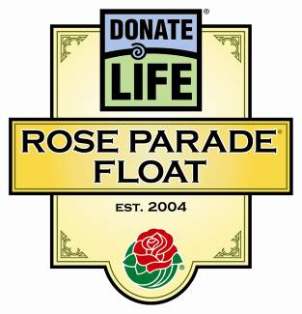
Donate Life Rose Parade® Float
All About Floragraphs

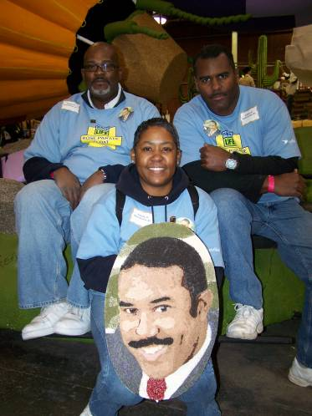
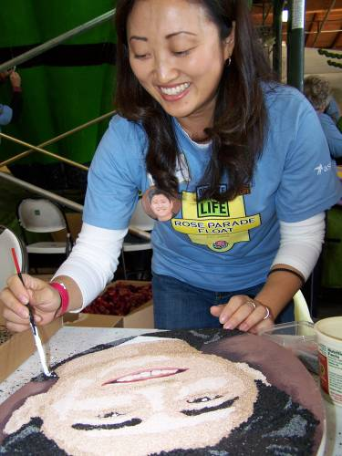
Continuing a tradition that began in the 2008 Rose Parade, Donate Life’s 2011 float entry will feature 60 “floragraphs” of organ, eye and tissue donors from across the country.

What is a floragraph?
A floragraph is a memorial portrait created with floral materials.

Who is featured on the Donate Life floragraphs?
The float’s Floragraph Sponsors select the deceased organ, eye and tissue donors who are depicted on the portraits.

How large are the floragraphs?
The size varies yearly depending on the float design. This year the floragraphs are 10” x 15” oval.

How are floragraphs created?
Photographs of the honored donors are converted into posterized images which are printed and applied to a foam or wood backing. The portraits are then decorated in a method akin to “color by number.” Donate Life volunteers experienced in the art of decorating floragraphs guide the donors’ families or selected volunteers – many of them donor family members or transplant recipients – through the deeply meaningful process of bringing the floragraph portraits to life.

How do floragraphs inspire people to donate life?
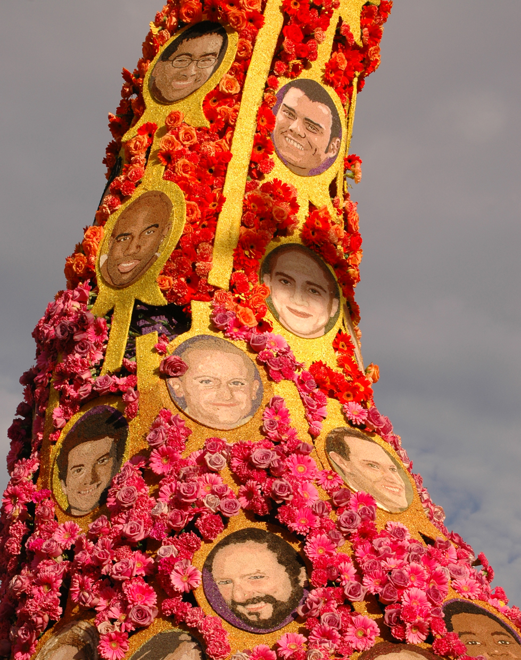
Floragraph families decorating portraits of their loved ones are compelling subjects for the media. In fact, the donors and families honored with floragraphs have been the subject of hundreds of news stories capturing the families’ meaningful participation in the Rose Parade. Together with the Donate Life float’s riders, the floragraphs are the centerpiece of the national media campaign surrounding Donate Life’s annual Rose Parade float entry.

Photos from top to bottom: Donor wife Kelly Sim of Renton, Wash. decorates a floragraph of her husband Johnathan. The Los Angeles family of Cecil Evans Sr. poses with his floragraph. Floragraphs adorn the 2010 Donate Life Rose Parade float, “New Life Rises.”

