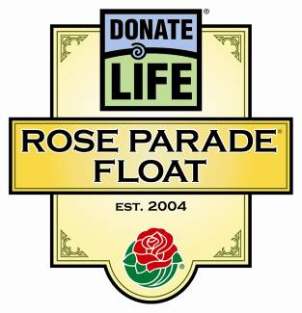
Donate Life Rose Parade® Float
All About Floragraphs

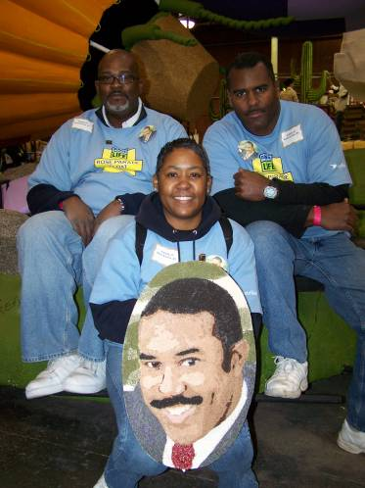
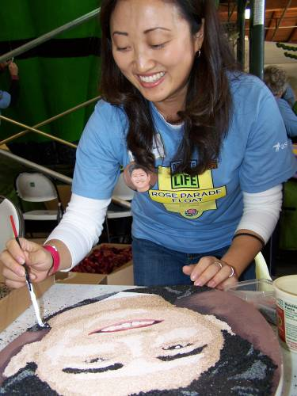
Continuing a tradition that began in the 2008 Rose Parade, Donate Life’s 2010 float entry will feature 76 “floragraphs” of organ, eye and tissue donors from across the country.

What is a floragraph?
A floragraph is a portrait created with floral materials.

Who is featured on the Donate Life floragraphs?
The float’s Floragraph Sponsors select the deceased organ, eye and tissue donors who are depicted on the floragraphs.

How large are the floragraphs?
The size varies according to the float design. Floragraphs have ranged from a 13” to 15” circle to an 18” x 24” oval. In 2010, the floragraphs are 12.5” x 17.5” oval.

How are floragraphs created?
Photographs of the honored donors are converted into posterized images which are printed and applied to wood. The portraits are then decorated in a method akin to “color by numbers”. Experienced detail artists guide volunteers – many of them members of the donor’s family and all touched by organ and tissue donation – through the deeply meaningful process of bringing the floragraphs to life.

How do floragraphs inspire people to donate life?
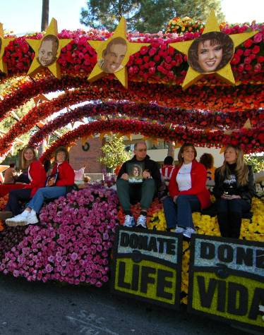
Floragraph families decorating portraits of their loved ones are compelling subjects for the media. In fact, Donate Life’s floragraphs were the primary subject of more than 250 news stories nationwide over two years’ time. Together with the float’s riders, the floragraphs are the centerpiece of the national media campaign surrounding Donate Life’s annual Rose Parade float entry.

Photos from top to bottom: Donor wife Kelly Sim of Renton, Wash. Decorates a floragraph of her husband Johnathan. The Los Angeles family of Cecil Evans Sr. poses with his floragraph. Floragraphs adorn the 2009 Donate Life Rose Parade float, “Stars of Life.”

