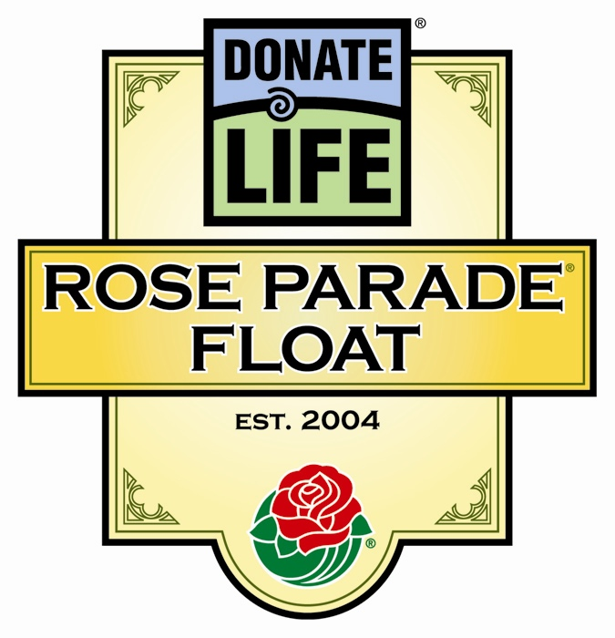
Donate Life Rose Parade® Float
Travel Yellow Pages

Travel Services
Pasadena AAA Travel Services | (626) 744-2870

Limo and Car Rental Information from Major Area Airports
Los Angeles International (LAX)
First Class Limo Service (Sun-Thurs; NO weekends & holidays) | (310) 676-9771
Limo Zone | (714) 612-1925
Avis Rent a Car | (800) 917-2847
Budget Rent a Car | (800) 446-3964
Enterprise Rent a Car | (800) 736-8222

Burbank (BUR)
First Class Limo Service (Sun-Thurs; NO weekends & holidays) | (818) 845-5212
Limo Zone | (714) 612-1925
Avis Rent a Car | (800) 917-2847
Budget Rent a Car | (800) 446-3964
Enterprise Rent a Car | (800) 736-8222

Orange County (SNA)
A Golden Limousine | (800) 561-5432
Limo Zone | (714) 612-1925
Avis Rent a Car | (800) 917-2847
Budget Rent a Car | (800) 446-3964
Enterprise Rent a Car | (800) 736-8222

Ontario (ONT)
Limo Zone | (714) 612-1925
Avis Rent a Car | (800) 917-2847
Budget Rent a Car | (800) 446-3964
Enterprise Rent a Car | (800) 736-8222

Avoid Traffic…Take the Train!
Metro Gold Line | http://www.ci.pasadena.ca.us/trans/transit/goldline/

Donate Life Rose Parade® Float
Travel Yellow Pages (cont’d)

Restaurants in Pasadena
* Bistro 45 | (626) 795-2478 | 45 S. Mentor Ave..
* Buca di Beppo | (626) 792-7272 | 80 W. Green St.
Cheesecake Factory | (626) 584-6000 | 2 W. Colorado Blvd..
* De Lacey’s Club 41 | (626) 795-4141 | 41 S. De Lacey Ave.
Denny’s | (626) 795-0192 | 2627 E. Colorado Blvd.
* El Cholo | (626) 441-4353 | 958 S. Fair Oaks Ave.
* El Portal | (626) 795-8553 | 695 E. Green St.
El Torito | (626) 351-8995 | 3333 E. Foothill Blvd.
Gaucho Grill | (626) 683-3580 | 121 W. Colorado Blvd.
* Gordon Biersch | (626) 449-0052 | 41 Hugus Alley
* Hilton Pasadena | (626) 577-1000 | 168 S. Los Robles Ave.
* Holly Street Bar & Grill | (626) 440-1421 | 175 E. Holly St.
Hooters | (626) 395-7700 | 96-998 E. Colorado Blvd.
*Il Fornaio | (626) 683-9797 | 24 W. Union
In ‘n’ Out Burger | (800) 786-1000 | 2114 E. Foothill Blvd.
* JJ’s Steakhouse | (626) 844-8889 | 88 W. Colorado Blvd.
* Madre’s | (626) 744-0900 | 897 Granite Dr.
* McCormick & Schmick’s | (626) 405-0064 | 111 N. Los Robles Ave.
* Mi Piace | (626) 795-3131 | 25 E. Colorado Blvd.
* Moose McGillicuddy’s | (626) 304-9955 | 119 E. Colorado Blvd.
* Parkway Grill | (626) 795-1001 | 510 S. Arroyo Parkway
* Smitty’s Grill | (626) 792-9999 | 110 S. Lake Ave.
* Twin Palms | (626) 577-2567 | 101 W. Green St.

* New Year’s Eve Celebrations – early reservations recommended
Call for reservations and information

Entertainment, Clubs and Bars Open on New Year’s Eve
Call for reservations and additional information
Twin Palms – restaurant, band, dancing | (626) 577-2567 | 101 W. Green St.
Burger Continental – restaurant, belly dancing | (626) 792-6634 | 535 S. Lake Ave.
Ice House – comedy club | (626) 577-1895 | 24 N. Mentor Ave.
Q’s Billiard Club – billiards, dancing | (626) 405-9777 | 99 E. Colorado Blvd.
The Muse – bar, dancing | (626) 793-0608 | 54 E. Colorado Blvd.

Donate Life Rose Parade® Float
Travel Yellow Pages (cont’d)

Places to Go and Things to Do In the Pasadena Area
Call for hours of operation 12/31/05 and 1/1/06
Descanso Gardens | (818) 949-4200 | 1418 Descanso Dr., La Cañada | Adults $5, Students $3,  Seniors 62+ $3, Kids 5-12 $1
Disney’s California Adventure | www.disneyland.com | 1313 S. Harbor Blvd., Anaheim | Theme park
Disneyland | www.disneyland.com | 1313 S. Harbor Blvd., Anaheim | Theme park
Downtown Disney | www.disneyland.com | 1313 S. Harbor Blvd., Anaheim | Entertainment district featuring selections in dining, entertainment & shopping
Huntington Library & Gardens | (626) 405-2100 | 1151 Oxford Rd., San Marino | Adults $10, Seniors $8.50,  Kids <5 Free, Kids 5-11 $4, Students 12-18 $7
Knott’s Berry Farm | www.knottsberryfarm.com | 8039 Beach Blvd., Buena Park | Theme park
Los Angeles County Arboretum | (626) 821-3222 | 301 N. Baldwin Ave., Arcadia | Adults $5, Seniors 62+ $3,  Kids 5-12 $1
Norton Simon Museum | (626) 449-6840 | 411 W. Colorado Blvd.., Pasadena | Adults $6, Seniors $3,  Kids<18 Free
Old Pasadena | (626) 666-4156  www.oldpasadena.com | Bordered by Arroyo Pkwy, Pasadena Ave., Walnut St. & Del Mar Blvd. in Pas. | 22-block area offers over 120 retail stores & boutiques, 80 restaurants & entertainment
One Colorado | (626) 564-1066 | 1 W. Colorado Blvd., Pasadena | Features nat’l retailers, specialty shops, restaurants
Paseo Colorado | (626) 795-8891 www.paseocolorado.com | Colorado Blvd. between Marengo Ave. & Los Robles Ave. in Pasadena | Open-air urban village with 65 street-front shops, 14-screen movie complex, 8 restaurants & cafes
The Playhouse District | (626) 744-0340 | Centered at Colorado Blvd. & El Molino Ave. in Pasadena | Anchored by the Pasadena Playhouse; features bookstores, antique & specialty shops, restaurants & historic architecture.
Santa Monica & Third Street Promenade | www.santamonica.com | Third Street, Santa Monica | Beaches, shopping, dining on a pedestrian mall
South Lake Ave. | (626) 792-1259 www.southlakeavenue.com | Bordered by California & Colorado Blvds., in Pasadena | 10-block tree-lined avenue featuring 600 retailers, boutiques, major dept. stores & European-style restaurants.
Universal Studios | www.universalstudioshollywood.com | 100 Universal City Plaza, Universal City | World’s largest movie studio & theme park
Universal CityWalk | www.universalstudioshollywood.com | 100 Universal City Plaza, Universal City | Entertainment district featuring selections in dining, entertainment & shopping

