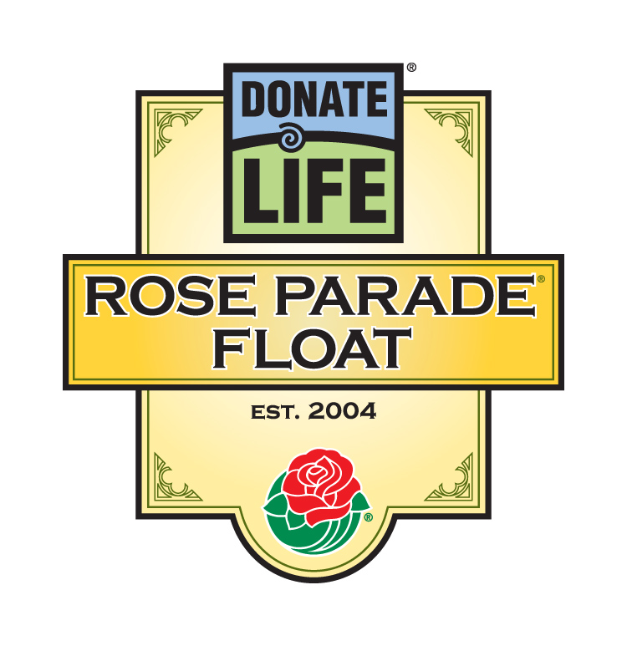

For Immediate Release

Contacts: Rivian Bell or Lisa Bernfeld, (213) 612-4927, (888) 477-4319 (24/7), rbell@jdipr.com, lbernfeld@jdipr.com

DONATE LIFE ROSE PARADE® FLOAT HONORS 14 DONATION AND TRANSPLANTATION LEADERS ON ‘STARS OF LIFE’ WALK OF FAME

LOS ANGELES, Calif. – Nov. 17, 2008 – On New Year’s Day, 14 men and women who have made exceptional contributions to organ, eye and tissue donation and transplantation will be honored with Walk of Fame stars on the 2009 Donate Life Rose Parade float, ‘Stars of Life’.

Inspired by the 2009 Rose Parade theme Hats Off To Entertainment and modeled after the Hollywood Walk of Fame, this cluster of stars honors luminaries in the field of donation and transplantation who have made a positive, lasting impact on organ, eye and tissue donation and transplantation through their contributions to medicine, the community, and public policy. From a pool of more than 60 nominations received through a national call for submissions, all 14 honorees were chosen by the float’s organizing committee, which includes participants from the full spectrum of donation, transplantation and affiliated healthcare organizations.
“We had a special opportunity this year to honor those who have worked diligently, year after year, to save lives through donation and transplantation,” said Tom Mone, member of the Donate Life float committee and chief executive officer and executive vice president at OneLegacy, the nonprofit organ and tissue recovery agency serving the greater Los Angeles area. “Some of our honorees are household names in their respective professions, others have pioneered organizations, campaigns and initiatives, and some have inspired people and communities worldwide to say ‘yes’ to donation. To all of these ‘Stars of Life,’ we simply say: thank you.”
The ‘Stars of Life’ Walk of Fame honorees include (in alphabetical order):
- Clive O. Callender, MD, FACS (Silver Spring, Md.), the senior African American transplant surgeon, founder of the National Minority Organ/Tissue Transplant Education Program (MOTTEP®), and expert on the relationship between minorities and organ and tissue donation and transplantation.
- Gary Foxen (Orange, Calif.), lung recipient and visionary whose idea for a Rose Parade float to reach a mass audience about donation resulted in the largest public relations campaign in the nation for organ, eye and tissue donation.
- MORE -
2009 Donate Life Rose Parade Float Walk of Fame
Page 2-2-2

- Reg Green (La Canada, Calif.), founder of The Nicholas Green Foundation, author and global ambassador for donation who, with his wife, Maggie, is internationally recognized as the “first family of donation” after the death of their young son, Nicholas, in Italy in 1994.
- Richard J. Kagan, MD, FACS (Cincinnati, Ohio), world-renowned burn care surgeon and prominent proponent of using human allogeneic skin grafts as the gold standard for burn care.
- Bill Lofthouse (1939-2008), donor husband and founder of Phoenix Decorating Co., one of the top producers of Rose Parade floats, whose generous support helped the Donate Life float evolve into a national tradition.
- Robert and Rafael Mendez, MD, FACS (Los Angeles, Calif.), kidney transplant surgeons and founders of OneLegacy, the nation’s largest organ and tissue recovery agency, and the National Institute of Transplantation.
- Kenneth Moritsugu, MD, PhD (Washington, D.C.), donor father and husband, former Acting Surgeon General of the U.S., and one of the nation’s most respected ambassadors of donation and transplantation.
- Joseph E. Murray, MD (Wellesley Hills, Mass.), recipient of the 1990 Nobel Prize in Medicine who conducted the world’s first kidney transplant, allograft transplant, and transplant of a kidney from a deceased donor.
- Barbara Schulman, RN, CPTC (Los Angeles, Calif.), co-founder and first president of the North American Transplant Coordinators Organization (NATCO).
- Thomas E. Starzl, MD, PhD (Le Mars, Iowa), groundbreaking surgeon who performed the world’s first successful liver transplant in 1967 and won the 2004 National Medal of Science for his innovation in transplantation medicine.
- Bryan Stewart (Northridge, Calif.), vice president of communications at OneLegacy, and chairman of the organizing committee for the Donate Life Rose Parade float, centerpiece of the nation's largest public relations campaign to inspire people to donate life.
- Tommy G. Thompson (Madison, Wis.), former Governor of Wisconsin and former Secretary of the U.S. Dept. of Health and Human Services whose initiatives include the first-ever state law mandating organ donation education in the classroom, and the Organ Donation and Transplantation Breakthrough Collaborative, a drive to increase organ donation rates nationwide through the sharing of best practices among hospitals.
- MORE -
2009 Donate Life Rose Parade Float Walk of Fame
Page 3-3-4

- Jesse White (Chicago, Ill.), Illinois Secretary of State whose advocacy of donation and the Illinois Organ/Tissue Donor Registry, the nation's first confidential computerized database allowing individuals to document their donor designations, is a model for the nation.
- James S. Wolf, MD (1935-2007), pioneer transplant surgeon whose vision of the value and need for public education and collaboration among organ, eye and tissue recovery organizations led to the founding of the Coalition on Donation (now Donate Life America).
More than 28,000 lives are saved each year in the U.S. through the gift of organ donation, giving hope to the more than 100,000 people awaiting a life-saving organ transplant. In addition, every year hundreds of thousands of people need donated corneas and tissue to prevent or cure blindness, heal burns or save limbs.
In addition to the Walk of Fame honorees, the float will feature 26 riders, among them transplant recipients, donor family members and a living donor, immersed in a shower of more than 100 stars. Among them are 38 gold stars with floragraph portraits of organ, eye and tissue donors, dozens of white stars to represent those among us who have been touched by donation, and four transparent stars to symbolize those in need of donated organs, corneas and tissue. The large orange-yellow stars at the front of the float will carry more than 1,000 roses dedicated through the float’s Family Circle program.
Coordinated by Donate Life America member OneLegacy, the Donate Life Rose Parade float is supported by 60 official partners from across the nation, including organ and tissue recovery organizations, tissue banks, state donor registries, transplant centers and affiliated organizations. Joining OneLegacy as top-level benefactors are Astellas Pharma US, Inc., a fourth-year sponsor of five float riders through the “Ride of a Lifetime” contest and supporter of 1,000 volunteer decorators; the American Association of Tissue Banks (AATB); Donate Life America; the Family Circle Rose Dedication Program; and the National Donor Memorial and UNOS. All float partners encourage parade viewers to save lives by registering in their states to be organ, eye and tissue donors and donating blood in their communities.
The 120th Rose Parade themed Hats Off To Entertainment will take place Thurs., Jan. 1, 2009, at 8 a.m. (PST) featuring majestic floral floats, high-stepping equestrian units and spirited marching bands showcasing the best in entertainment. Following the Rose Parade, at 2 p.m. (PST), the 95th Rose Bowl Game® will feature an exciting match-up between two championship teams, once again showcasing the best of collegiate football. For additional information on Tournament of Roses® please visit the official website at www.tournamentofroses.com.
For more information about the Donate Life Rose Parade Float, visit the official float website at www.donatelifefloat.org.
# # #
(Editor’s Note: List of official partners is attached.)

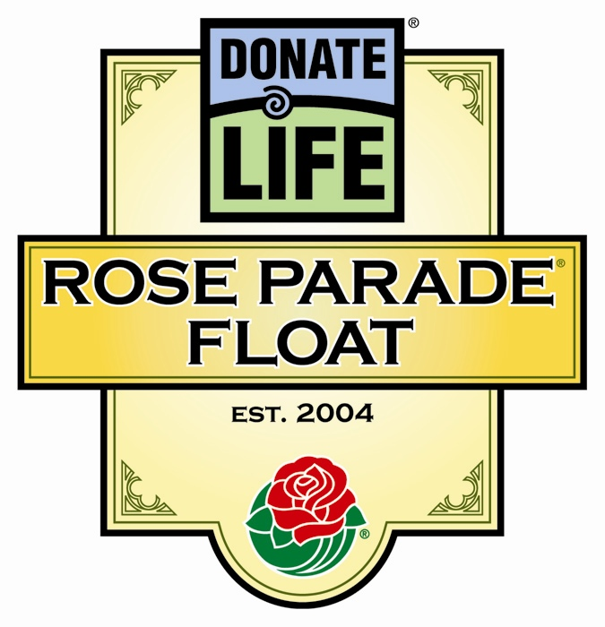
Donate Life Rose Parade® Float
2009 Official Partners

Benefactors

Astellas Pharma US, Inc.
American Association of Tissue Banks (AATB)
Donate Life America
Family Circle Rose Dedication Program
OneLegacy
National Donor Memorial and UNOS

Float Rider Sponsors

AlloSource
American Association of Tissue Banks (AATB)
Astellas Pharma US, Inc.
California Transplant Donor Network
Cedars-Sinai Comprehensive Transplant Center
Center for Donation & Transplant
Donate Life California
Donate Life Indiana
Donor Alliance, Inc.
Donor Network of Arizona
Gift of Hope Organ & Tissue Donor Network
Musculoskeletal Transplant Foundation
OneLegacy
RTI Donor Services
St. Joseph Hospital Kidney Transplant Program
Transplants for Children
Upstate New York Transplant Services
Vesta Therapeutics, Inc.

Floragraph Sponsors

American Association of Tissue Banks (AATB)
CryoLife, Inc.
Dignity Memorial
Donate Life Run/Walk Committee
Finger Lakes Donor Recovery Network
Gift of Life Donor Program
Iowa Donor Network
Life Alaska Donor Services
Life Alliance Organ Recovery Agency
LifeBanc
LifeCell Corporation
Lifeline of Ohio
Lifesharing
LifeSource
Living Legacy at LifeCenter Northwest
The Living Legacy Foundation of Maryland
Loma Linda University Medical Ctr. Transplantation Institute
Louisiana Organ Procurement Agency
Mid-America Transplant Services
Mid-South Transplant Foundation, Inc.
Midwest Transplant Network
Minnesota Lions Eye Bank
National Institute of Transplantation
NJ Sharing Network
Transplants for Children
UCLA Health System
Washington Regional Transplant Community

Float Sponsors

Health Promotions Now
Phoenix Decorating Co.
Sallop Insurance Agency

Contributing Sponsors

Association of Organ Procurement Organizations (AOPO)
International Transplant Nurses Society (ITNS)
JDI Communications, Inc.
Renal Support Network
TRIO West County/Ventura County

RP41-072908

