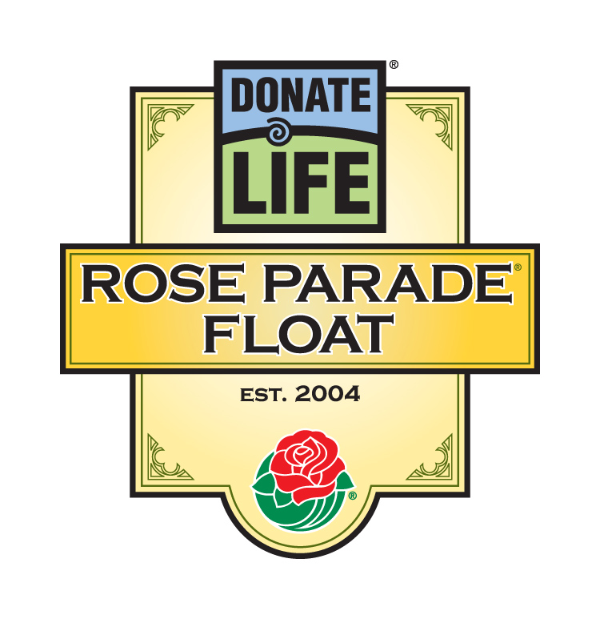

For Immediate Release

Contacts: Bryan Stewart, (213) 401-1226 or bstewart@onelegacy.org
Rivian Bell (rbell@jdipr.com) or Lisa Bernfeld (lbernfeld@jdipr.com)
(213) 612-4927, (888) 477-4319 (24/7)

DONATE LIFE rose parade® FLOAT TO FEATURE 40 ‘floragraphs’ OF ORGAN, EYE AND TISSUE DONORS WHOSE GIFTS OF LIFE AIDED THOUSANDS

‘Life Takes Flight’ as Donor Families from 15 States
Decorate Floral Portraits of Loved Ones

LOS ANGELES, Calif. – Nov. 5, 2007 – The photos of their smiling faces – many of them still young – look as if they were taken just yesterday. But the faces gracing the Donate Life Rose Parade float are those of organ, eye and tissue donors who in their passing saved, healed and gave hope to thousands of people in need. And come December, more than 30 of these donors’ families will travel from 15 states to Pasadena to transform images of their loved ones into “floragraphs” that will adorn the Donate Life float, Life Takes Flight, in the 2008 Rose Parade.

Floragraphs are artistic portraits created by using spices, seeds, and other organic materials to cover a digitized photograph of the individual. The final image is astonishingly realistic, recognizable and a fitting memorial to organ, eye and tissue donors everywhere.

“Each image represents a unique story of an individual with a loving family and recipients who are thankful of their gifts of life. One girl, a heart donor, was only two months old, while a 64-year-old father donated his organs, eyes and tissue,” noted Bryan Stewart, chairman of the float organizing committee and vice president of communications for OneLegacy, the non-profit, federally designated organ and tissue recovery agency serving the greater Los Angeles area. “As their families bring these floragraphs to life, they will honor the legacy of their loved ones and all donors: gifts that offer life, hope and health to people in need. The process of creating these portraits, as well as the float’s five-mile journey down Colorado Boulevard, will bring the donation story to life for millions to see.”

One of the floragraphs will depict Julie De Rossi, a free-spirited mother from Houston, Tex. whose interests ranged from racecar driving to interior design. A drunk driver ended her life, but her donated organs and tissue helped some 35 people. Among them was Carson Palmer, the star Cincinnati Bengals quarterback and former Heisman Trophy winner, whose recovery from a crushing knee injury was assisted by the gift of Julie’s tissue.

Also honored will be Johnathan Sim of Renton, Wash., whose work for international relief and development organization World Vision allowed him to do what he loved most: saving the lives of kids around the world in such countries as North Korea, Sri Lanka, Uganda, and Zambia. After Johnathan died unexpectedly in 2005, his wife knew that the 33-year-old father of two would have wanted nothing more than to leave a legacy of life for others, which he did by donating his kidneys, liver and heart.

-MORE-

2008 Donate Life Rose Parade Floragraphs
Page 2-2-2

Another floragraph belongs to Cecil Evans, Sr., a Los Angeles man who was known for helping others in need. One day, after viewing a TV show about organ and tissue donation, he decided to sign up as a donor. His decision was reinforced when his son-in-law, who had been on dialysis for years, received a new kidney in 1999. When a massive stroke ended his life at 54, Cecil’s liver saved the life of a 63-year old mother and grandmother.

David Starr of Blue Springs, Mo., a 19-year-old engineering student at the University of Missouri, became an organ and tissue donor after a fatal auto accident on January 26, 1991. His brother Kit, touched by how transplant recipients live their lives so fully, decided to donate one of his kidneys if the opportunity ever arose, which it did in 2003. Kit affirmed, “If an organ donation could have saved David, and someone gave him that chance, just think how different our lives would have been.”

Also remembered on the Donate Life float will be baby Trinity Periera of Banning, Calif., who was only two months old when she died from head injuries on July 7, 2002. Trinity’s heart was successfully transplanted into a three-month old Missouri boy, who is now six. “Although I was unable to see Trinity crawl, walk or go to school,” said her mother Marlin, “she is able to do all those things through someone else’s eyes. She is his little life angel.”

The 2008 Donate Life Rose Parade float features a balloon festival, with four colorful hot air balloons rising 30 feet high above 24 riders whose lives have been saved and renewed by organ, eye, tissue and blood donors. Eight donor family members will walk alongside the float, each holding tether lines connecting them to floragraphs of their loved ones.

Hundreds of individuals, families and organizations touched by donation and transplantation will join the riders and walkers as float participants through the Family Circle Rose Dedication Program, which was founded by Laurie Wolowic, who will walk alongside the float linked to the floragraph of her brother Michael Wolowic of Lake Zurich, Ill. More than 1,000 roses will carry personal messages of love, remembrance and gratitude from around the world, adding an international dimension reflecting the parade’s theme, Passport to the World’s Celebrations.

Coordinated by Donate Life America member OneLegacy, the Donate Life float is supported by more than 50 official partners from across the nation, including organ and tissue recovery organizations, transplant centers, non-profit and for-profit contributors, and transplant recipient organizations. Joining OneLegacy as top-level benefactors are Astellas Pharma US, Inc., sponsor of five float riders and the volunteer decorating team for a third consecutive year; the Family Circle Rose Dedication Program; and the National Donor Memorial and UNOS (United Network for Organ Sharing). All float partners encourage parade viewers to become registered organ, eye and tissue donors in their states and donate blood in their communities.

The 119th Rose Parade will take place Tuesday, Jan. 1, 2008 at 8 a.m. (PST) featuring majestic floral floats, high-stepping equestrian units and spirited marching bands from throughout the world. Following the Rose Parade, at 2 p.m. (PST), the 94th Rose Bowl Game will feature an exciting match-up between two championship teams, once again showcasing the best of collegiate football.

Complete information is available online at www.donatelifefloat.org.

# # #
(Editor’s note: A list of floragraph honorees follows)
Donate Life Rose Parade® Float
2008 Floragraph Honorees

Name | Donation | Date | Age | Sex | Hometown | Honored by
Elizabeth Aguilar | Organ, Tissue and Eye Donor | 1/4/05 | 19 | F | Lancaster, CA | OneLegacy
Hernán Aispuro* | Organ Donor | 2/16/99 | 6 | M | Los Angeles, CA | OneLegacy
Tanya Austin | Organ Donor | 10/27/01 | 27 | F | Easley, SC | Inetz Media Group  and Donate Life South Carolina
Sarah Braun | Organ, Tissue and Eye Donor | 1/17/02 | 21 | F | Pella, IA | Iowa Donor Network
Kasey Burleson | Organ and Tissue Donor | 11/24/05 | 16 | F | Columbus, OH | Lifeline of Ohio
Erin Choe | Cornea Donor | 9/2/06 | 5 | F | Fullerton, CA | OneLegacy
Raymond Costlow | Organ, Tissue and Eye Donor | 4/22/07 | 64 | M | Anaheim, CA | Classic Cruisers of Orange County
Julie De Rossi | Organ, Tissue and Eye Donor | 3/18/04 | 44 | F | Houston, TX | Sallop Insurance Agency  and LifeGift Organ Donation Center
Nicholas Ermak | Organ, Tissue and Eye Donor | 6/10/06 | 22 | M | Pleasanton, CA | UCLA Healthcare
Jonathan Eshenour | Organ Donor | 7/17/97 | 12 | M | Hershey, PA | Gift of Life Donor Program
Cecil Evans, Sr. | Organ Donor | 11/12/02 | 54 | M | Los Angeles, CA | OneLegacy
Christopher Field | Tissue and Eye Donor | 7/29/05 | 16 | M | Middleton, MA | Donate Life Float Committee  and New England Organ Bank
Ana Maria Flores* | Organ Donor | 8/12/00 | 30 | F | Miami, FL | Life Alliance Organ Recovery Agency
Steven Ginoza | Organ Donor | 5/14/00 | 28 | M | Honolulu, HI | Donate Life Float Committee  and Organ Donor Center of Hawaii
Dan Gromada Jr. | Organ Donor | 6/26/04 | 19 | M | Canfield, OH | LifeBanc
Paul Hickey | Organ and Eye Donor | 11/21/99 | 26 | M | Lexington, KY | National Institute of Transplantation  and Kentucky Organ Donor Affiliates
Jemil Jamison | Organ Donor | 4/4/02 | 23 | M | Winchester, CA | OneLegacy
Karlynn Johnson | Organ Donor | 10/30/05 | 28 | F | Mora, MN | LifeSource
Juan Juaregui | Organ and Tissue Donor | 5/12/03 | 23 | M | Norwalk, CA | OneLegacy
Gretchen Lofthouse | Cornea Donor | 5/25/04 | 59 | F | Pasadena, CA | Donate Life Float Committee
James McGuire* | Organ and Eye Donor | 1/16/06 | 5 | M | Portland, OR | CryoLife, Inc.
Katie Moore* | Organ, Tissue and Eye Donor | 6/4/06 | 17 | F | Baton Rouge, LA | Louisiana Organ Procurement Agency
Melanie Moore* | Organ, Tissue and Eye Donor | 3/26/07 | 48 | F | Baton Rouge, LA | Louisiana Organ Procurement Agency
Allen T. Murray* | Tissue and Eye Donor | 1/3/99 | 49 | M | Silver Spring, MD | Washington Regional Transplant Community
* Donor family member walker to accompany float

- MORE -
Donate Life Rose Parade® Float
2008 Floragraph Honorees (cont’d)

Name | Donation | Date | Age | Sex | Hometown | Honored by
Lisa Marie Odgers | Consented Donor | 5/28/04 | 18 | F | Norco, CA | OneLegacy
Stephanie Pasquale | Tissue Donor | 11/26/05 | 42 | F | Orange, CA | Donate Life Run/Walk Committee
Trinity Pereira | Organ Donor | 7/10/02 | 2 mos | F | Banning, CA | OneLegacy
Dennis Rivetti | Organ and Eye Donor | 2/5/04 | 48 | M | Littlerock, CA | OneLegacy
Johnathan Sim | Organ Donor | 7/26/05 | 33 | M | Renton, WA | Living Legacy Foundation
Jacob C. Smith | Organ and Eye Donor | 2/19/07 | 18 | M | Millington, TN | Mid-South Transplant Foundation, Inc.
Terry Lee Snow | Organ and Eye Donor | 3/11/98 | 19 | M | Riverside, CA | OneLegacy
Robert Somerville | Organ Donor | 9/4/96 | 16 | M | Marcellus, NY | Finger Lakes Donor Recovery Network
Dana Spencer | Organ Donor | 1/2/97 | 16 | F | Ballwin, MO | Mid-America Transplant Services
Heather Spindler | Organ Donor | 9/5/06 | 21 | F | Edgewater, MD | The Living Legacy Foundation of Maryland
David Starr | Organ, Tissue and Eye Donor | 1/26/91 | 19 | M | Blue Springs, MO | Midwest Transplant Network
Nicholas Stone* | Organ Donor | 6/21/06 | 23 | M | Greeley, CO | Donor Alliance
Ransom Tipton* | Organ Donor | 5/5/05 | 16 | M | Waleska, GA | LifeLink Foundation
Michael Wolowic* | Organ and Tissue Donor | 11/28/02 | 50 | M | Lake Zurich, IL | Donate Life Float Committee
Brian Rand Wos | Organ, Tissue and Eye Donor | 9/5/06 | 19 | M | San Diego, CA | Lifesharing
* Donor family member walker to accompany float

# # #

