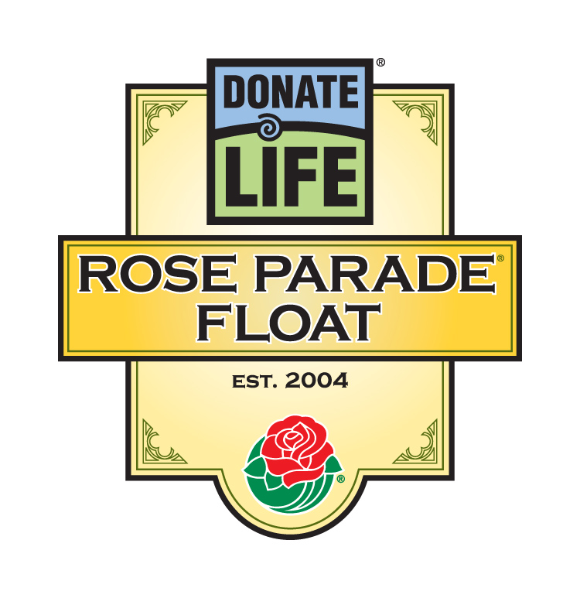

For Immediate Release

Contacts: Bryan Stewart, (213) 401-1226 or bstewart@onelegacy.org
Rivian Bell or Lisa Bernfeld, (213) 612-4927, (888) 477-4319 (24/7), rbell@jdipr.com, lbernfeld@jdipr.com

24 AMERICANS SAVED BY ORGAN, EYE, TISSUE, AND BLOOD DONATION TO RIDE THE DONATE LIFE FLOAT IN THE 2008 ROSE PARADE®
‘Life Takes Flight’ When Transplant Recipients from 13 States
Inspire Others to Give the Gift of Life

LOS ANGELES, Calif. – Sept. 17, 2007 – They are of all ages and a rainbow of ethnic backgrounds. They live in the country’s biggest cities and smallest towns. And for all 24 of them, their lives would have been very different except for one thing: the generosity of others. They all lead productive lives today because someone donated the organs, eyes, tissue and blood they so desperately needed.

These 24 people will show one million spectators, 40 million U.S. viewers and people in 150 other countries what it means to have received the gift of life as they ride the fifth Donate Life float entry, Life Takes Flight, in the 2008 Rose Parade to inspire others to commit to being donors. The 24 riders, selected by 18 sponsoring organizations across the country, have received collectively kidneys, hearts, lungs, livers, corneas, bone, ligaments, and blood. They will ride on a 30-foot high float carrying four hot air balloons symbolizing how their lives are lifted to new heights by the generosity of donors.

“This is the first year that the Donate Life float riders are all transplant recipients,” confirmed Bryan Stewart, chairman of the float organizing committee and director of communications for OneLegacy, the non-profit, federally designated organ and tissue recovery agency serving the greater Los Angeles area. “We have one of our most ethnically and demographically diverse group of riders, who range in age from 15 to 63. Their stories of hardship, hope and renewal should inspire thousands of people who never considered donation of organs, eyes, tissue, or blood to do so. Donations have allowed each rider’s life to take flight, and their examples will give hope to others who wait desperately for the gift of life.”

Five of the 24 riders are students. Others work in the arts, education, healthcare, landscape design, real estate, government, and entertainment. Two are retired from their professions, but work in their communities. They live in Arizona, California, Colorado, Florida, Kansas, Illinois, Missouri, Nevada, New Mexico, New York, Pennsylvania, Tennessee, and Wisconsin. Some have met the family members of those who gave the ultimate gift; others still wait for that opportunity.

- MORE -
2008 Donate Life Rose Parade Float Riders
Page 2-2-2

Each has a story to tell, including Jill Miller of Saegertown, Pa., who was 26 when her kidneys suddenly failed after an undiagnosed bout of strep throat. A donor’s kidney saved her life, which was threatened a year later by advanced breast cancer. As she says, the kidney “saved my life twice” because it allowed her to undergo chemotherapy and fight off the cancer. Almost a dozen years later, Miller is a physician providing medical care in an underserved community.

Miller will ride with Tom Berryhill, the only elected official in the United States who is a heart transplant recipient. A fourth-generation California farmer, Berryhill serves in the California State Assembly representing the people of Modesto and advocating for donation. Another heart recipient, Alvin Grant of Albany, N.Y., was a college student when sudden cardiomyopathy put his life in immediate jeopardy. The gift of life from an organ donor meant that Grant could return to college with the prospect of becoming a graphic designer.

Teenagers Sarah Lopez of Albuquerque, N.M., Indra Michaca of Moreno Valley, Calif., and D.J. Lampert of St. Louis, Mo. have never met, yet they have shared similar experiences: all are alive today because of liver transplants. Lopez received hers at age six from another six-year-old, Angel Marie Garcia. “Because they said yes to donation, I am alive today,” Lopez acknowledged gratefully. Lampert received his liver at only eight months of age, and he has dedicated his young life to “pass along my story, speaking from the heart” so that other students will understand the importance of donation.

Nikki Cortez of Greeley, Colo. and Monica Montgomery of Shawnee, Kan. also have a common link. Acute lymphocytic leukemia forced Cortez to undergo masses of chemotherapy and corticosteroids, which severely weakened her bones. Bone grafts and an elbow transplant have allowed her to thrive. Similarly, Montgomery was rescued from a life of canes and crutches by a massive donor bone graft, including ligaments and cartilage, which saved a severely damaged leg broken in a simple neighborhood game of soccer.

“Most of us live each day without thinking that our lives could change in a moment. For our riders, their lives changed instantaneously because someone else thought enough to share what was no longer needed,” Stewart noted. “The shortage in organs is only increasing, with nearly 100,000 people now on the national transplant waiting list. We can make a difference in the lives of people in our community if we commit to being organ, eye, tissue, and blood donors.”

The riders on this year’s float will be surrounded by thousands of roses dedicated by individuals, families and organizations nationwide through the Family Circle Rose Dedication Program. Through the Family Circle program, donors, recipients and transplant candidates are honored with roses bearing personal messages of love, remembrance and gratitude. Some of those dedicating roses will make a pilgrimage to Pasadena to place their roses on the float in person. Roses can be dedicated through the official Donate Life float website, www.donatelifefloat.org.

- MORE -
2008 Donate Life Rose Parade Float Riders
Page 3-3-3

Dedicated roses from all 50 states and various countries amid this “festival of life” will bring special meaning to the parade’s theme, Passport to the World’s Celebrations. The float’s four hot air balloons will carry 40 floragraphs – artistic portraits created with floral materials – of deceased donors from across the country. Accompanying the 30-foot-high float will be eight donor family members walking in memory of loved ones who helped others live. The Donate Life float walkers will be announced October 1, and the floragraph honorees will be revealed November.

Coordinated by Donate Life America member OneLegacy, the Donate Life float is supported by more than 50 official partners from across the nation, including organ and tissue recovery organizations, transplant centers, non-profit and for-profit contributors, and transplant recipient organizations. Joining OneLegacy as top-level benefactors are Astellas Pharma US, Inc., sponsor of five float riders and the volunteer decorating team for a third consecutive year; the Family Circle Rose Dedication Program; and the National Donor Memorial and UNOS (United Network for Organ Sharing). All float partners encourage parade viewers to become registered organ, eye and tissue donors in their states and donate blood in their communities.

The 119th Rose Parade will take place Tuesday, Jan. 1, 2008 at 8 a.m. (PST) featuring majestic floral floats, high-stepping equestrian units and spirited marching bands from throughout the world. Following the Rose Parade, at 2 p.m. (PST), the 94th Rose Bowl Game will feature an exciting match-up between two championship teams, once again showcasing the best of collegiate football.

Complete information is available online at www.donatelifefloat.org.

# # #
(Editor’s note: Capsules for each of the float riders follow.)
Donate Life Rose Parade® Float
2008 Float Riders

Name | Rel'ship to Donation | Age | Sex | Hometown | Occupation | Sponsored by
Jan Barney | Cornea recipient | 51 | M | Elk Grove, CA | DMV manager | Donate Life California/DMV
His story: | For years, Jan Barney wore contact lenses that ultimately scratched his eyes severely. Cornea transplants kept him from blindness and gave him back his sight, which was essential for Jan’s work with the California Department of Motor Vehicles.
Tom Berryhill | Heart recipient | 54 | M | Modesto, CA | Assemblymember/  Farmer | Donate Life California
His story: | Tom Berryhill’s work as a farmer and elected public servant would have ended without a heart transplant. Today, he serves diligently in the California State Assembly on behalf of his constituents. He recently co-authored the state’s revised Uniform Anatomical Gift Act (UAGA) bill and is the only elected official in the U.S. who is a heart transplant recipient.
Isabel Stenzel Byrnes | Lung recipient | 35 | F | Redwood City, CA | Social worker/  Health educator | California Transplant Donor Network
Her story: | Isabel Stenzel Byrnes and her twin sister have both been afflicted with cystic fibrosis since birth. They also shared writing a book after both received double lung transplants. Isabel’s lungs have allowed her to run relays, climb mountains, and hike the Grand Canyon.
Tracy Copeland | Liver recipient | 43 | F | Sparks, NV | Accounting manager | Astellas Pharma US, Inc.
Her story: | Tracy Copeland’s life was saved by an organ donor after her liver failed for still unknown reasons. Tracy reached out to her donor family early on, and now the parents of Tracy's 19-year-old donor, Terry Lee Snow, cheer Tracy on to medal-winning feats at the U.S. and World Transplant Games.
Nikki Cortez | Bone recipient | 21 | F | Greeley, CO | Patient services coordinator | AlloSource
Her story: | As a teenager, Nikki Cortez’s treatment for acute leukemia took a great toll on the bones in her body. Her mobility continues to be restored by tissue grafts, including a left knee replacement and the first elbow transplant in the United States.
Dale Wade Davis | Kidney recipient | 38 | M | North Hollywood, CA | Journalist/Actor/  Comedian | NKF Team Southern California
His story: | In October 2006, multiple-Emmy award winner Dale Wade Davis was diagnosed with a hereditary kidney disease. After more than 30 friends volunteered for testing as potential donors, the best match turned out to be Dale’s good friend Phillip Palmer, morning news anchor for ABC7 in Los Angeles
Paul DiLorenzo | Blood recipient | 28 | M | Riverside, CA | Graduate student | Blood Bank of San Bernardino and Riverside Counties
His story: | A genetic blood disorder has required Paul DiLorenzo to receive blood every three weeks. In his 25 years, he has received more than 2,000 units, given anonymously by people to whom Paul always says “thank you!”
Ron Geddes | Lung recipient | 58 | M | Clarence, NY | Bus driver (Retired) | Upstate New York Transplant Services
His story: | Ron Geddes’ lungs were damaged from scleroderma, an autoimmune disease. His transplanted lungs came as a rare Christmas gift, allowing Ron to become more athletic, celebrate his 34th wedding anniversary, and walk his daughter down the aisle.

- MORE -
Donate Life Rose Parade® Float
2008 Float Riders (cont’d)

Name | Rel'ship to Donation | Age | Sex | Hometown | Occupation | Sponsored by
Dawn Giese | Tissue recipient | 45 | F | Shawano, WI | Registered nurse, ER | Regeneration Technologies  Donor Services
Her story: | Dawn Giese’s work as a registered nurse was limited because of a spinal stress fracture. The only answer to the crippling back pain was a transplant using donated bone tissue. She now lives a full life as a nurse, wife, mother and donation advocate.
Claire Goudeau | Liver recipient | 56 | F | Madison, WI | Nurse | Astellas Pharma US, Inc.
Her story: | Claire Goudeau’s life as a nurse could not prepare her for liver failure, which left her confused and emaciated. Thanks to a liver transplant, she now cares for her aging parents and volunteers to encourage others to commit to being organ donors.
Alvin Grant | Heart recipient | 20 | M | Albany, NY | Student | Center for Donation & Transplant
His story: | Alvin Grant started college happily, not suspecting cardiomyopathy would put him on the waiting list for a heart transplant. With his new heart, he is finishing school and hopes to educate others as to how “the decision to donate can save lives."
Ozzie Herrera | Kidney recipient | 49 | M | Orange, CA | Landscape contractor | St. Joseph Hospital Kidney Transplant Program
His story: | Ozzie Herrera spent five years waiting for a kidney transplant that would free him from dialysis. The transplant took place on Thanksgiving, which now holds special meaning for Ozzie and his family.
George Hill | Tissue, kidney recipient | 50s | M | Nashville, TN | University Professor and Associate Dean | LifeCell Corp.
His story: | An avid runner in his 50s, Prof. George Hill of Vanderbilt University endured a medical marathon that included several complex surgeries, renal failure and, ultimately, a kidney transplant and reconstruction of his abdominal wall with donated allograft skin.
Bill Ismer | Heart recipient | 63 | M | Plant City, FL | Law enforcement (retired) | Astellas Pharma US, Inc.
His story: | Bill Ismer’s severe heart attack put him at death’s door. He survived many months before a donor heart became available. William ultimately married his favorite cardiac nurse, saying “I waited all year for my heart, and when I got it, I gave it away.”
Kelli Jaunsen | Heart/liver recipient | 23 | F | Palm Desert, CA | Photographer/  Digital artist | Cedars-Sinai Comprehensive Transplant Program
Her story: | Kelli Jaunsen has never known life without serious health problems, including congenital heart defects and liver failure. She received a heart and liver transplant that she calls “a double gift of life.”
Jesse Kolb | Lung recipient | 15 | M | Tucson, AZ | Student | Donor Network of Arizona
His story: | Jesse Kolb lived with cystic fibrosis for 11 years until donor lungs became available. He can now run, enjoy sports, and play guitar. Jesse has a future but never forgets what it was like before the transplant: “The waiting list is too long. We all need to help shorten it.”

- MORE -
Donate Life Rose Parade® Float
2008 Float Riders (cont’d)

Name | Rel'ship to Donation | Age | Sex | Hometown | Occupation | Sponsored by
D.J. Lampert | Liver recipient | 17 | M | St. Louis, MO | High school student | Astellas Pharma US, Inc.
His story: | D.J. Lampert was just a baby when he received a liver transplant from a baby girl. Now a teenager, D.J. gives back by speaking to other students and helping others who wait for the gift of life.
Sarah Felice Lopez | Liver recipient | 18 | F | Albuquerque, NM | Student | Vesta Therapeutics, Inc.
Her story: | Sarah Felice Lopez was born with a damaged liver. She fought to stay alive until age six, when she received a liver from a girl her own age, giving Sarah a new life.
Bennie Marshall | Liver recipient | 52 | M | Chicago, IL | Airline ramp agent | Gift of Hope Organ & Tissue Donor Network
His story: | Bennie Marshall is passionate about bringing the message of donation to the African-American community. The liver transplant that saved his life is proof to him that “donation is non-discriminate.”
Indra Michaca | Liver recipient | 19 | F | Moreno Valley, CA | Student | Loma Linda University Medical Center Transplantation Institute
Her story: | In one week, Indra Michaca went from kidney stones to a coma to a liver transplant. Now a college student, she and her sister Zulma work diligently to inspire students and the community to sign up on the Donate Life California Organ & Tissue Donor Registry.
Jill Miller | Kidney recipient | 39 | F | Saegertown, PA | Resident physician, Family practice | Astellas Pharma US, Inc.
Her story: | Jill Miller’s sudden kidney failure and time on dialysis convinced her to help others as a physician. After receiving a kidney transplant, she went on to create a green ribbon-adorned beanie bear to inspire people to donate life, a precursor to her company Charity Bear. She now practices medicine in an underserved area.
Monica Montgomery | Tissue recipient | 44 | F | Shawnee, KS | Financial aid officer | Musculoskeletal Transplant Foundation
Her story: | Monica Montgomery’s leg shattered during a community soccer scrimmage. The only way she could hope to walk normally again was through grafts of donated bone, ligaments, and cartilage. She is now thankful for every strong step she takes.
Jesus Nava | Heart recipient | 63 | M | West Covina, CA | Real estate sales | OneLegacy
His story: | Jesus Nava experienced a heart attack and stroke that led to the need for a new heart. He spent a year hospitalized until a young African-American teenager donated his heart. Since then, Jesus has reopened his real estate business, met his donor’s mother, and volunteered in the hospital to help others waiting for live-saving organs.
Daniel Ronco | Kidney recipient | 50 | M | Moreno Valley, CA | Community volunteer | OneLegacy
His story: | After two kidney transplants, Daniel Ronco became a community volunteer. Noting that “I want to help other people who need help,” he supports a local food ministry, the local organ and tissue recovery agency, and his stroke-ridden mother.

# # #

