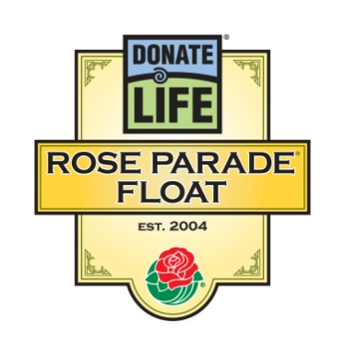

For Immediate Release

Contacts: Bryan Stewart, (213) 229-5650 or bstewart@onelegacy.org
Rivian Bell, (213) 612-4927, (888) 477-4319 (24/7) or rbell@jdipr.com

2014 DONATE LIFE FLOAT TO INSPIRE ROSE PARADE® VIEWERS TO
‘LIGHT UP THE WORLD’ AS LIFESAVING DONORS

Lantern Design with Riders, Walkers and Floragraphs to
Spotlight Importance of Organ, Eye and Tissue Donation

LOS ANGELES, Calif. – June 17, 2013 – More than 70 organizations supporting Donate Life America’s lifesaving mission unveiled their 11th Donate Life Rose Parade float: “Light Up the World,” a festival of beautiful lanterns which will inspire viewers worldwide to save and heal lives through organ, eye and tissue donation. The Donate Life float and its honored participants are the centerpiece of a national campaign that leads up to the 2014 Rose Parade.

“We were inspired by the theme of the 125th Rose Parade, ‘Dreams Come True,’ to reflect on how our dreams are illuminated by the examples of others,” said Bryan Stewart, chairman of the Donate Life Rose Parade Float Committee and vice president of communications at OneLegacy, the non-profit organ and tissue recovery organization serving the seven-county greater Los Angeles area. “Through their life-changing experiences, individuals and families touched by organ and tissue donation and transplantation shine a light on us all. Transplant recipients radiate with gratitude and renewed life thanks to the gifts of organ, eye and tissue donors; families of deceased donors rekindle their spirits by carrying on their loved ones’ dreams; and both living and registered donors are beacons of hope to patients who aspire to live longer, fuller lives. Like lanterns illuminating the night sky above or the path before us, those who give and receive the gift of life light up the world with their compassion and courage.”

The 2014 Donate Life Rose Parade Float entry features a festival of lanterns illuminating 30 riders – all grateful organ and tissue transplant recipients – and 12 living organ donors walking alongside to demonstrate their ongoing vitality. The float’s five enormous lanterns are adorned with 72 memorial floragraph portraits of deceased donors whose legacies of life shine brightly. The riders are seated throughout a dedication garden filled with thousands of roses bearing personal messages of love, hope and remembrance.

Since its debut on New Year’s Day 2004, the Donate Life Rose Parade float has become the world’s most visible campaign to inspire people to become organ, eye, and tissue donors. The campaign began as an idea expressed in a letter by lung recipient Gary Foxen of Orange, Calif., who wanted to show gratitude to donors who make life-saving transplants possible. Now, in addition to the 40 million viewers who view the Rose Parade in the stands and on TV, hundreds of events are held in cities and towns around the country to put the finishing touches on floragraph portraits and present dedicated roses to donor families and community partners that play a role in making donation possible.
- MORE -
2014 Donate Life Rose Parade Float
2-2-2

The 2014 Donate Life float is built by Phoenix Decorating Company from a design by Dave Pittman and is coordinated by Donate Life America member OneLegacy. Each year, the Donate Life float campaign is supported by more than 140 official sponsors from coast to coast, including organ and tissue recovery organizations, tissue and eye banks, hospitals, transplant centers, state donor registries, funeral homes, donor family foundations and affiliated organizations. Joining OneLegacy as top-level benefactors are the Dignity Memorial® network, North America’s largest network of funeral, cremation and cemetery service providers; the American Association of Tissue Banks (AATB); Donate Life America; the Orange County-based Donate Life Run/Walk Committee; The Order of St. Lazarus; SightLife; and TBI/Tissue Banks International. To date all 30 recipient float riders, 12 living donor walkers and 62 of 72 floragraphs have been sponsored.

“Every single person who takes action to be a donor gives hope to the nearly 120,000 people across America waiting for their dream – a life-saving organ transplant – to come true,” said Stewart. One person can save up to eight lives through the donation of lifesaving organs – heart, kidney, liver, lungs, pancreas and small intestine – and help 50 people or more who need corneas to see, skin to heal from burns, and bones and connective tissue for common knee, back and dental surgeries. In addition, approximately 6,000 lives per year are saved by living kidney and liver donors.

The Donate Life Rose Parade Float’s family of sponsors urges viewers to help make dreams come true for more than one million people in need of life-saving and healing organ, tissue and cornea transplants. Join America’s 110 million registered donors so that everyone whose life and livelihood depends on a transplant can have one. Sign up when renewing your driver’s license or by visiting www.DonateLifeAmerica.org. Further information about the Donate Life float can be found at www.donatelifefloat.org.

The Pasadena Tournament of Roses is a volunteer organization that annually hosts the Rose Parade® presented by Honda, Rose Bowl Game® presented by VIZIO and various associated events. The 125th Rose Parade presented by Honda, themed “Dreams Come True,” will take place Wednesday, Jan. 1, 2014, at 8 a.m. (PST) featuring majestic floral floats, high-stepping equestrian units and spirited marching bands. Following the parade, the 100th Rose Bowl Game presented by VIZIO will kick off at 2:10 p.m. and feature an exciting match-up between two of the top collegiate football teams in the nation. For additional information on the Tournament of Roses please visit the official website at www.tournamentofroses.com.

# # #
(Editor’s Note: The float rendering and list of official sponsors as of June 2013 are attached.)

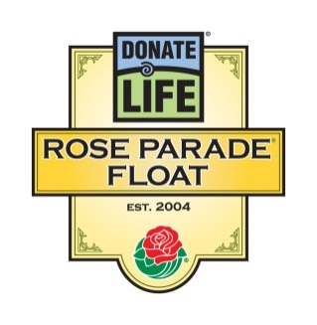
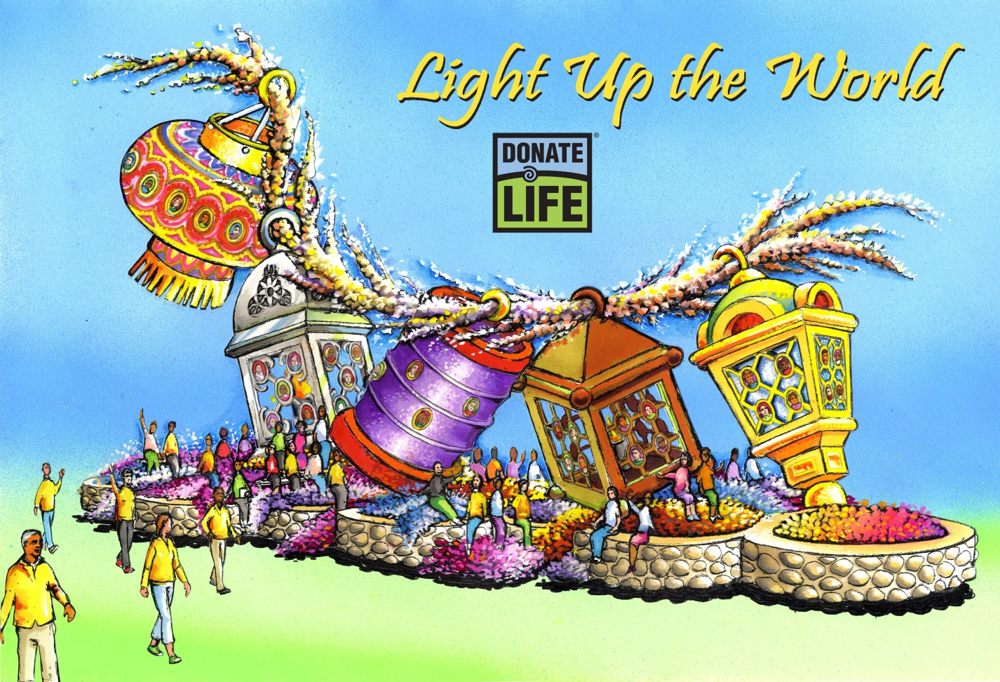
“Light Up the World”
Individuals and families touched by organ and tissue donation and transplantation shine a light on us all. Transplant recipients radiate with gratitude and renewed life thanks to the gifts of organ, eye and tissue donors; families of deceased donors rekindle their spirits by carrying on their loved ones’ dreams; and both living and registered donors are beacons of hope to patients who aspire to live longer, fuller lives. Like lanterns illuminating the night sky above or the path before us, those who give and receive the gift of life Light Up the World with their compassion and courage.
The 2014 Donate Life Rose Parade Float entry features a festival of lanterns illuminating 30 riders – all grateful organ and tissue transplant recipients – and 12 living organ donors walking alongside to demonstrate their ongoing vitality. Five enormous lamps are adorned with 72 memorial floragraph portraits of deceased donors whose legacies of life shine brightly. The riders are seated throughout a dedication garden filled with thousands of roses bearing personal messages of love, hope and remembrance.
Donate Life urges viewers to help make dreams come true for more than one million people in need of life-saving and healing organ, tissue and cornea transplants. Join America’s 110 million registered donors so that everyone whose life and livelihood depends on a transplant can have one. Sign up when renewing your driver’s license or by visiting DonateLifeAmerica.org.
Donate Life Rose Parade® Float
2014 Official Sponsors

Benefactors

American Association of Tissue Banks (AATB)
Dignity Memorial
Donate Life America
Donate Life Run/Walk Committee
OneLegacy
The Order of St. Lazarus
SightLife
TBI/Tissue Banks International

Participant Sponsors (Rider, Walker, Floragraph)

Alabama Organ Center ^{F}
AlloSource ^{R}
American Association of Tissue Banks (AATB) ^{RF}
ARORA (Arkansas Regional Organ Recovery Agency) ^{F}
Bacterin International ^{WF}
Bridge to Life, Ltd. ^{F}
Buddhist Tzu Chi Medical Foundation ^{RF}
California Transplant Donor Network ^{RF}
Cedars-Sinai Comprehensive Transplant Center ^{W}
Center for Donation & Transplant ^{F}
CORE ^{F}
CryoLife, Inc. ^{F}
Cytonet, LLC ^{R}
Dignity Memorial ^{F}
Donate 4 Life ^{R}
Donate Life California ^{RF}
Donate Life Northwest ^{F}
Donate Life Run/Walk Committee ^{RW}
Donor Alliance, Inc. ^{R}
Donor Network of Arizona ^{RF}
Emory Transplant Center ^{R}
Finger Lakes Donor Recovery Network ^{RF}
Gift of Hope Organ & Tissue Donor Network ^{WF}
Gift of Life Donor Program ^{RF}
Indiana Organ Procurement Organization (IOPO) ^{RF}
Iowa Donor Network ^{RF}
JJ's Legacy ^{F}
Joseph H. Helfgot Foundation ^{F}
Kentucky Organ Donor Affiliates ^{F}
Life Alliance Organ Recovery Agency ^{F}
LifeGift ^{R}
Lifeline of Ohio ^{F}
LifeShare Transplant Donor Services of Oklahoma ^{RF}
Lifesharing ^{F}
LifeSource ^{F}
Living Donation California ^{RW}
Living Legacy Foundation of Maryland ^{F}
Loma Linda Univ. Medical Center Transplantation Institute ^{W}
Louisiana Organ Procurement Agency ^{F}
Lucey Mortgage Corporation ^{R}
Medtronic Spinal and Biologics ^{R}
Mendez National Institute of Transplantation ^{F}
Mid-America Transplant Services ^{F}
Mid-South Transplant Foundation, Inc. ^{F}
Midwest Transplant Network ^{F}
Minnesota Lions Eye Bank ^{F}
Mississippi Organ Recovery Agency ^{F}
Musculoskeletal Transplant Foundation ^{R}
New England Organ Bank ^{F}
NJ Sharing Network Foundation ^{R}
OneLegacy ^{RWF}
The Order of St. Lazarus ^{R}
RTI Donor Services ^{RF}
Ryan Viator's Legacy ^{RF}
Sallop Insurance Agency ^{F}
Sierra Donor Services ^{F}
SightLife ^{F}
Taylor's Gift Foundation ^{R}
TBI/Tissue Banks International ^{F}
Tennessee Donor Services ^{F}
TransLife ^{F}
UCLA Health System ^{W}
Unyts ^{R}
Washington Regional Transplant Community ^{F}

Contributing Sponsors

JDI Communications, Inc.
LifeLink Foundation
Phillips 66
Phoenix Decorating Co.
Renal Support Network
TRIO Ventura County/West Valley Chapter

as of 6/17/13

