

For Immediate Release

Contacts: Bryan Stewart, (213) 229-5650 or bstewart@onelegacy.org
Rivian Bell, (213) 612-4927, (888) 477-4319 (24/7) or rbell@jdipr.com

NEW LIFE RISES AT 2010 ROSE PARADE®
TO INSPIRE PEOPLE TO SIGN UP ON ORGAN AND TISSUE DONOR REGISTRIES

Donate Life’s Seventh Float Entry Features Mythical Phoenix Soaring Above Donor Memorial

LOS ANGELES, Calif. – June 16, 2009 – A nationwide partnership of organizations united to inspire all people to “Donate Life” through organ, eye and tissue donation unveiled New Life Rises as its 2010 Rose Parade float entry today at the Donate Life America Spring 2009 Meeting in St. Louis, Mo. The float, which marks the seventh appearance of the donation and transplant community in the Rose Parade, is designed to inspire more than 30 million U.S. television viewers to give the gift of life by signing up to be organ and tissue donors on their respective state registries.
Donate Life’s new creation features a phoenix, the mythical symbol of life coming out of the ashes of death, rising from a bed of flames into the sky. The Donate Life phoenix represents those who give life in their passing and the people whose lives are renewed through transplantation. The bird soars high above 24 float riders – all transplant recipients, living donors, and family members of deceased donors – seated along a Wall of Names inspired by the National Donor Memorial at the headquarters of the United Network for Organ Sharing (UNOS) in Richmond, Va., the organization chosen by the government to operate the national organ donation and transplantation network.
The phoenix’s tail feathers are adorned with dozens of floragraphs – portraits created with floral materials – that depict loved ones who gave life to those in need. In addition, donors across the country will be memorialized in a garden of roses dedicated through the Donate Life Family Circle program, with each rose vial carrying a personal message of love, hope and remembrance.
The Donate Life float adds a meaningful dimension to the 2010 Rose Parade theme, 2010: A Cut Above the Rest. “Just as the Tournament of Roses® strives each year to host a Rose Parade that is better than the last, our expanding Donate Life community is challenged to present float entries that are increasingly inspiring,” said Bryan Stewart, chairman of the Donate Life float committee and vice president of communications at OneLegacy, the nonprofit organ and tissue recovery organization serving the greater Los Angeles area. “We believe this new creation will accomplish that mission.”
“Each year in the U.S., about 28,000 lives are saved through the gift of organ donation, while hundreds of thousands of people receive donated corneas and tissue to prevent or cure blindness, heal burns, save limbs and restore mobility,” said David Fleming, president and CEO of Donate Life America. “We hope the beauty and boldness of New Life Rises inspires parade spectators and viewers to rise up and join the more than 82 million Americans who have registered as organ, eye and tissue donors, helping us reach our national goal of 100 million designated donors.”
- MORE -
2010 Donate Life Rose Parade Float
2-2-2
The 2010 Donate Life float, built by Phoenix Decorating Co. from a design by Dave Pittman, features two key elements inspired by the National Donor Memorial: the Wall of Names running the length of the float and the Wall of Tears encircling the dedicated roses at each end. The UNOS memorial, which honors America’s organ, eye and tissue donors with a 10,000-square-foot memorial garden and a website of tributes to donors, serves as the national transplant community’s commemoration of America’s donors. More information about the National Donor Memorial is available at www.donormemorial.org.
Coordinated by Donate Life America member OneLegacy, the Donate Life float campaign is supported by approximately 60 official partners from coast to coast, including organ and tissue recovery organizations, tissue banks, state donor registries, transplant centers and affiliated organizations. Joining OneLegacy as top-level benefactors are Astellas Pharma US, Inc., a fifth-year sponsor of five float riders through the “Ride of a Lifetime” contest and supporter of 1,000 volunteer decorators; the American Association of Tissue Banks (AATB); the Dignity Memorial® network, North America’s largest network of funeral, cremation and cemetery service providers and sponsor of four floragraphs; Donate Life America; and UNOS and the National Donor Memorial. All float partners encourage parade viewers to save lives by registering in their states to be organ, eye and tissue donors and donating blood in their communities.
The Pasadena Tournament of Roses is a volunteer organization that annually hosts the Rose Parade and Rose Bowl Game® presented by Citi. The 121st Rose Parade will take place Friday, Jan. 1, 2010, at 8 a.m. (PST) featuring majestic floral floats, high-stepping equestrian units and spirited marching bands. Following the Rose Parade, the 96th Rose Bowl Game presented by Citi will kick off at 2:10 p.m. and feature an exciting match-up between two of the top teams in the country.
On Jan. 7, the Tournament of Roses will also host the No. 1 and No. 2 BCS-ranked teams in the 2010 Citi BCS National Championship Game. The Game will kick off at 5 p.m. (PST) from the historic Rose Bowl Stadium. For additional information about the Tournament of Roses® please visit the official website at www.tournamentofroses.com.
For more information about the Donate Life Rose Parade Float, visit the official float website at www.donatelifefloat.org.
# # #
(Editor’s Note: The float rendering and list of official partners as of June 2009 are attached.)


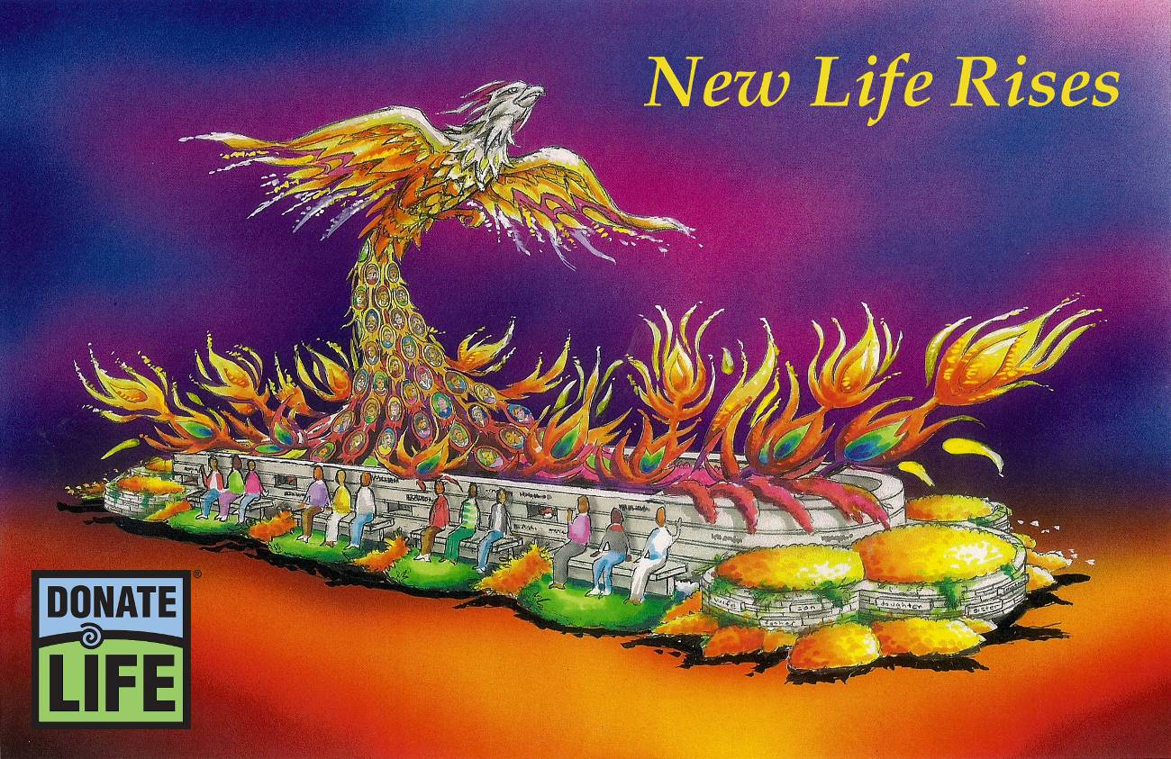

“New Life Rises”

When people say “Yes” to organ, eye and tissue donation, New Life Rises, giving hope and healing to those in need of life-saving transplants. In Donate Life’s seventh Rose Parade float entry, a phoenix, the mythical symbol of life coming out of death, rises into the sky, representing those who give life in their passing and the people whose lives are renewed by their gifts.

From a bed of nurturing flames, the majestic phoenix rises anew, its tail feathers adorned with
40 floragraphs – portraits created with floral materials – depicting loved ones who gave life to those in need. The bird soars high above 24 float riders – all transplant recipients, living donors, and family members of deceased donors – seated along a monument inspired by the National Donor Memorial’s Wall of Names. A garden inspired by the memorial’s Wall of Tears leads the float with 2,000 dedicated roses, each carrying a personal message of love, gratitude and hope to a donor, recipient or candidate for transplant.

More than 82 million Americans have said “Yes” to saving lives by enrolling with their state organ and tissue donor registries. Join them today by visiting Donate Life America at www.donatelife.net.

Donate Life Rose Parade® Float
2010 Official Partners

Benefactors

Astellas Pharma US, Inc.*
American Association of Tissue Banks (AATB)*#
Dignity Memorial Network#
Donate Life America
OneLegacy*#
National Donor Memorial and UNOS

Float Rider Sponsors

AlloSource
California Transplant Donor Network
Cedars-Sinai Comprehensive Transplant Center
Center for Donation & Transplant
Donate Life California Organ & Tissue Donor Registry
Donate Life Run/Walk Committee
Donor Network of Arizona
Gift of Hope Organ & Tissue Donor Network
Indiana Organ Procurement Organization (IOPO)
Loma Linda University Medical Ctr. Transplantation Institute
Musculoskeletal Transplant Foundation (MTF)
RTI Donor Services
SightLife
Upstate New York Transplant Services

Floragraph Sponsors

CryoLife, Inc.
Donate Life Run/Walk Committee
Donate Life Today at LifeCenter Northwest
Donor Alliance, Inc.
Donor Network of Arizona
Finger Lakes Donor Recovery Network
Golden State Donor Services
Iowa Donor Network
Lifeline of Ohio
Lifesharing
LifeSource
The Living Legacy Foundation of Maryland
Louisiana Organ Procurement Agency (LOPA)
Mendez National Institute of Transplantation
Mid-America Transplant Services
Mid-South Transplant Foundation, Inc.
Midwest Transplant Network
NJ Sharing Network
Spencer Squire All-Star Foundation
St. Vincent Medical Center
UCLA Health System
Washington Regional Transplant Community

Float Sponsors

Loma Linda Eye Foundation

Contributing Sponsors

Association of Organ Procurement Organizations (AOPO)
Friends of Mike Salazar
Health Promotions Now
JDI Communications, Inc.
NATCO, The Organization for Transplant Professionals
Phoenix Decorating Co.
TRIO Ventura County/West Valley Chapter

as of 6/16/09
* includes float rider sponsorship
# includes floragraph sponsorship

