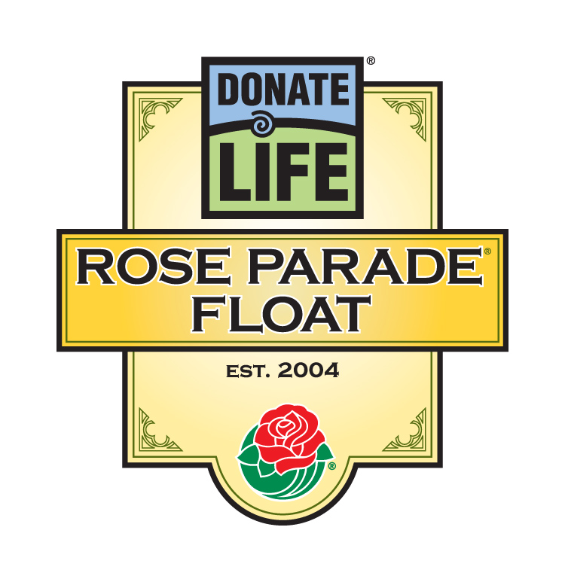

For Immediate Release

Contacts: Bryan Stewart, (213) 229-5650 or bstewart@onelegacy.org
Rivian Bell, (213) 612-4927, (888) 477-4319 (24/7) or rbell@jdipr.com

2012 Donate life Rose PARADE® Float IMAGINES …oNE mORE DAY
TO CELEBRATE AND SAVE LIVES

Amid Beautiful Floral Timepieces and a 30-Foot Clock Tower,
Organ, Eye and Tissue Donors and Recipients Reinforce the Preciousness of Time

LOS ANGELES, Calif. – June 14, 2011 – Ask anyone whose loved one gave life in their passing, or anyone waiting for a life-saving organ transplant what they wish for most. Many would answer the same way: more time. On Jan. 2, 2012, transplant recipients, living donors, and family members of deceased donors will join together to honor the preciousness of …One More Day on the ninth Donate Life Rose Parade float entry, a partnership of more than 100 organizations dedicated to inspiring people to save and heal lives through the donation of organs, eyes and tissue.
“Donate Life’s float theme is a deeply emotional coda to the 2012 Rose Parade theme, Just Imagine…”, said Bryan Stewart, chairman of the Donate Life Rose Parade Float Committee and vice president of communications at OneLegacy, the nonprofit organ and tissue recovery organization serving the greater Los Angeles area. “The opportunity to live, or relive, a precious moment in time inspires us to Just Imagine...One More Day when donor families are reunited with loved ones, transplant recipients thrive, and living and registered donors step forward so that a life-saving transplant is available to everyone in need.”
With a design inspired by floral clocks and clock towers from around the world, the 2012 Donate Life Rose Parade float will carry up to 28 donor family members, living donors, and transplant recipients. Six enormous floral timepieces will be adorned with 64 memorial “floragraphs” (floral portraits) of deceased donors whose gifts gave life and time to so many. A rose dedication garden honors more than 3,000 people worldwide; each rose will bear a vial with a personal message honoring a loved one. Anchoring the float is a 30-foot clock tower with a sun/moon dial reminding us to make each passing day count.
The Donate Life Rose Parade float has become the nation’s most visible campaign to inspire people to become organ, eye, and tissue donors. The concept originated with lung recipient Gary Foxen of Orange, Calif., who wanted to express gratitude to donors who make transplantation possible. Now, in addition to the 40 million viewers who will see the Rose Parade, dozens of events are held in cities and towns around the country to put the finishing touches on floragraph portraits and present dedicated roses to donor families. This last year alone, the Donate Life float generated more than 500 media stories nationwide.
- MORE -
2012 Donate Life Rose Parade Float
2-2-2
“Since the Donate Life float made its first appearance in 2004, more than 50 million Americans have signed up as donors on their state donor registries,” said David Fleming, president and CEO of Donate Life America. “However, the circumstances that allow for organ donation are very rare, so just as every day counts, so does every donation opportunity. We hope that anyone who has not yet registered will be inspired by Donate Life’s float to join the 100 million Americans who have checked ‘Yes’ for donation when applying for or renewing their driver’s license or identification card.”
The 2012 Donate Life float is built by Phoenix Decorating Co. from a design by Dave Pittman and is coordinated by Donate Life America member OneLegacy. The Donate Life float campaign is supported by more than 100 official sponsors from coast to coast, including organ and tissue recovery organizations, tissue banks, state donor registries, transplant centers, hospitals, funeral homes and affiliated organizations. Joining OneLegacy as top-level benefactors are the Dignity Memorial® network, North America’s largest network of funeral, cremation and cemetery service providers; the American Association of Tissue Banks (AATB); Donate Life America; and the United Network for Organ Sharing (UNOS) and the National Donor Memorial. All Donate Life float sponsors encourage parade viewers to save lives by registering in their states to be organ, eye and tissue donors and donating blood in their communities.
For more information about the Donate Life Rose Parade Float, visit the official float website at www.donatelifefloat.org.
The Pasadena Tournament of Roses is a volunteer organization that annually hosts the Rose Parade® presented by Honda, Rose Bowl Game® presented by VIZIO and various associated events. The 123rd Rose Parade presented by Honda, themed Just Imagine…, will take place Monday, Jan. 2, 2012, at 8 a.m. (PST) featuring majestic floral floats, high-stepping equestrian units and spirited marching bands. Following the parade, the 98th Rose Bowl Game presented by VIZIO will kick off at 2:10 p.m. and feature an exciting match-up between two of the top collegiate football teams in the nation. For additional information on the Tournament of Roses please visit the official website at www.tournamentofroses.com.
# # #
(Editor’s Note: The float rendering and list of official partners as of June 2011 are attached.)

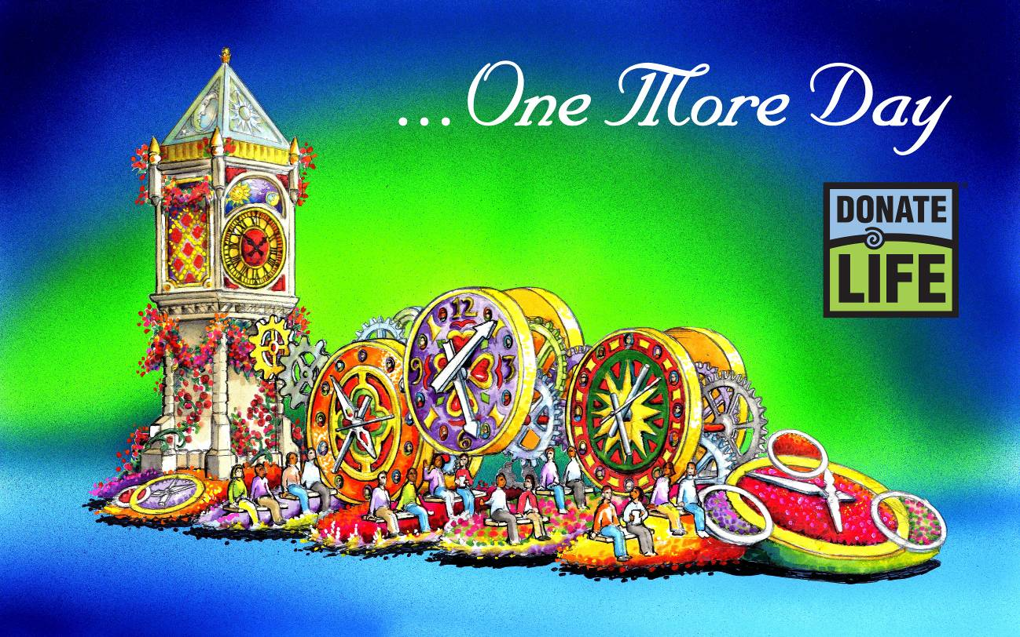

“…One More Day”

Through their life-changing experiences, the families of organ and tissue donors, living donors, and recipients of life-saving transplants know intimately the preciousness of time. On Jan. 2, 2012, transplant recipients, living donors, and family members of deceased donors will join together to honor the preciousness of …One More Day on the ninth Donate Life Rose Parade float entry.

Inspired by floral clocks and clock towers from around the world, the 2012 Donate Life Rose Parade float will carry up to 28 donor family members, living donors, and transplant recipients. Six enormous floral timepieces will be adorned with 64 memorial “floragraphs” (floral portraits) of deceased donors whose gifts gave life and time to so many. A rose dedication garden honors more than 3,000 people worldwide; each rose will bear a vial with a personal message honoring a loved one. Anchoring the float is a 30-foot clock tower with a sun/moon dial reminding us to make each passing day count.

Just as every day counts, so does every donation opportunity. Donate Life hopes that anyone who has not yet registered will be inspired by Donate Life’s float to join the 100 million Americans who have checked ‘Yes’ for donation when applying for or renewing their driver’s license or identification card.” Sign up as an organ, eye and tissue donor today by visiting www.donatelife.net.
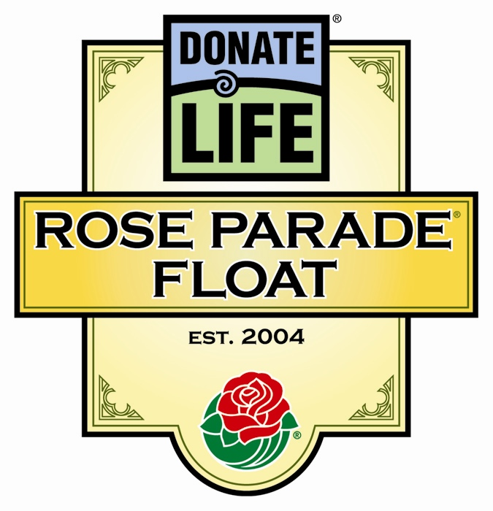
Donate Life Rose Parade® Float
2012 Official Partners

Benefactors

American Association of Tissue Banks (AATB)
Dignity Memorial Network
Donate Life America
OneLegacy
UNOS and National Donor Memorial

Float Rider Sponsors

AlloSource
American Association of Tissue Banks (AATB)
California Transplant Donor Network
Cedars-Sinai Comprehensive Transplant Center
Center for Donation & Transplant
Cytonet, LLC
Donate Life Run/Walk Committee
Donor Alliance, Inc.
Donor Network of Arizona
Finger Lakes Donor Recovery Network
Gift of Hope Organ & Tissue Donor Network
Gift of Life Donor Program
Indiana Organ Procurement Organization (IOPO)
Iowa Donor Network
LifeCenter Northwest
Loma Linda University Med. Ctr. Transplantation Institute
Mayo Clinic Transplant Center
Musculoskeletal Transplant Foundation (MTF)
OneLegacy (3)
RTI Donor Services
UKRO (University Kidney Research Organization)
Upstate New York Transplant Services

Floragraph Sponsors

American Association of Tissue Banks (AATB)
Bridge to Life, Ltd.
Buddhist Tzu Chi Medical Foundation
Center for Donation & Transplant
Dignity Memorial (8)
Donate 4 Life
Donate Life California
Donate Life Run/Walk Committee
Donor Network of Arizona
Finger Lakes Donor Recovery Network
Frankie Hernandez Legacy of Life Tournaments
Gift of Life Michigan (2)
Golden State Donor Services
Indiana Organ Procurement Organization (IOPO)
Iowa Donor Network
In Memory of Todd Sato
JJ's Legacy
Kentucky Organ Donor Affiliates
The Kingdom Kids
Life Alliance Organ Recovery Agency
Lifeline of Ohio
Lifesharing
LifeSource
The Living Legacy Foundation of Maryland
Louisiana Organ Procurement Agency
Mendez National Institute of Transplantation
Mid-America Transplant Services
Mid-South Transplant Foundation, Inc.
Midwest Transplant Network
OneLegacy (6)
Sallop Insurance Agency
Salt Creek Grille
SightLife
Spencer Squire All-Star Foundation
UCLA Health System
Washington Regional Transplant Community

Contributing Sponsors

GOAL Productions
In Memory of Michael E. Creighton
JDI Communications, Inc.
Morlin Asset Management LP
NATCO, The Organization for Transplant Professionals
Phoenix Decorating Co.
TRIO Ventura County/West Valley Chapter

as of 6/14/11

