

For Immediate Release

Contacts: Bryan Stewart, (213) 229-5650 or bstewart@onelegacy.org
Rivian Bell, (213) 612-4927, (888) 477-4319 (24/7) or rbell@jdipr.com

REAL-LIFE STARS of organ and tissue donation
TO SHINE ABOARD DONATE LIFE FLOAT IN 2009 ROSE PARADE ®

Breakthrough Float Design to Honor ‘Stars of Life’
Who Inspire Through Organ, Eye, Tissue, and Blood Donation

LOS ANGELES, Calif. – June 10, 2008 – A nationwide partnership of organizations united to inspire all people to “Donate Life” through organ, eye, tissue and blood donation unveiled its 2009 Rose Parade float design today at the Donate Life America Spring 2008 Meeting in Phoenix.
The 2009 Donate Life float, themed Stars of Life, marks the sixth appearance of the donation and transplant community in the Rose Parade, which attracts one million spectators, more than 30 million U.S. television viewers, and a broadcast audience in 150 countries. Stars of Life shines a spotlight on organ, eye, tissue and blood donation as 24 transplant recipients, living donors, and family members of deceased donors are immersed in a spectacular shower of stars representing all the people who make the gift of life possible.
“Donors and recipients of organs, eyes, tissue and blood are the real ‘Stars of Life’”, said Bryan Stewart, chairman of the Donate Life float committee and vice president of communications at OneLegacy, the nonprofit organ and tissue recovery agency serving the greater Los Angeles area. “Anyone can be a star and save lives by signing up to be an organ, eye and tissue donor on your state donor registry and by donating blood in your community.”
The Donate Life float adds a meaningful dimension to the 2009 Rose Parade theme, Hats Off To Entertainment. “Our hats go off to the real-life stars who make organ, eye, tissue and blood donation an inspiring story of courage, compassion, hope and renewal,” said David Fleming, Executive Director of Donate Life America. “More than 28,000 lives are saved each year in the U.S. through the gift of organ donation, giving hope to the nearly 100,000 awaiting a life-saving organ transplant. In addition, every year hundreds of thousands of people need donated corneas and tissue to prevent or cure blindness, heal burns or save limbs. One out of three people will need donated blood in their lifetime.”
Among the Donate Life float’s “Stars of Life” are 30 gold stars with floragraphs – artistic portraits created with floral materials – depicting loved ones whose donations of organs, corneas and/or tissue saved and healed those in need. Families of the donors depicted in the
- MORE -
2009 Donate Life Rose Parade Float
2-2-2

floragraphs will journey cross-country to Pasadena in the weeks before the Parade to decorate the portraits of their loved ones. White stars will represent those among us who have been touched by donation, while transparent stars will symbolize those in need of donated organs, corneas and tissue. The large orange-yellow stars at the front of the float will carry more than 1,000 roses dedicated through the Family Circle program, with each carrying a personal message of love, gratitude and hope to a donor, recipient or candidate in need of a transplant. Last year, dedicated roses came from 50 states and 21 countries.
One year after guiding Donate Life to its first-ever award, the Special Judges’ Trophy for showmanship and dramatic impact, Phoenix Decorating Co. will construct an abstract float design by Dave Pittman. “We are proud to design a float that is as unique and beautiful as the gift of life itself,” said Bill Lofthouse, founder of Phoenix Decorating. “As the husband of a cornea donor, I am deeply moved to contribute to the life-affirming message of the Donate Life float, whose purpose and hundreds of dedicated volunteers bring tremendous passion and meaning to the parade each and every year.”
Coordinated by Donate Life America member OneLegacy, the Donate Life float is supported by nearly 60 official partners from across the nation, including organ and tissue recovery organizations, tissue banks, state donor registries, transplant centers and affiliated organizations. Joining OneLegacy as top-level benefactors are Astellas Pharma US, Inc., a fourth-year sponsor of five float riders through the “Ride of a Lifetime” contest and supporter of 1,000 volunteer decorators; the American Association of Tissue Banks (AATB); Donate Life America; the Family Circle Rose Dedication program; and UNOS and the National Donor Memorial. All float partners encourage parade viewers to save lives by registering in their states to be organ, eye and tissue donors and donating blood in their communities.
The 120th Rose Parade themed Hats Off To Entertainment will take place Thurs., Jan. 1, 2009 at 8 a.m. (PST) featuring majestic floral floats, high-stepping equestrian units and spirited marching bands showcasing the best in entertainment. Following the Rose Parade, at 2 p.m. (PST), the 95th Rose Bowl Game® will feature an exciting match-up between two championship teams, once again showcasing the best of collegiate football. For additional information on Tournament of Roses® please visit the official website at www.tournamentofroses.com.
For more information about the Donate Life Rose Parade Float, visit the official float website at www.donatelifefloat.org.
# # #
(Editor’s Note: The float rendering and list of official partners as of June 2008 are attached.)


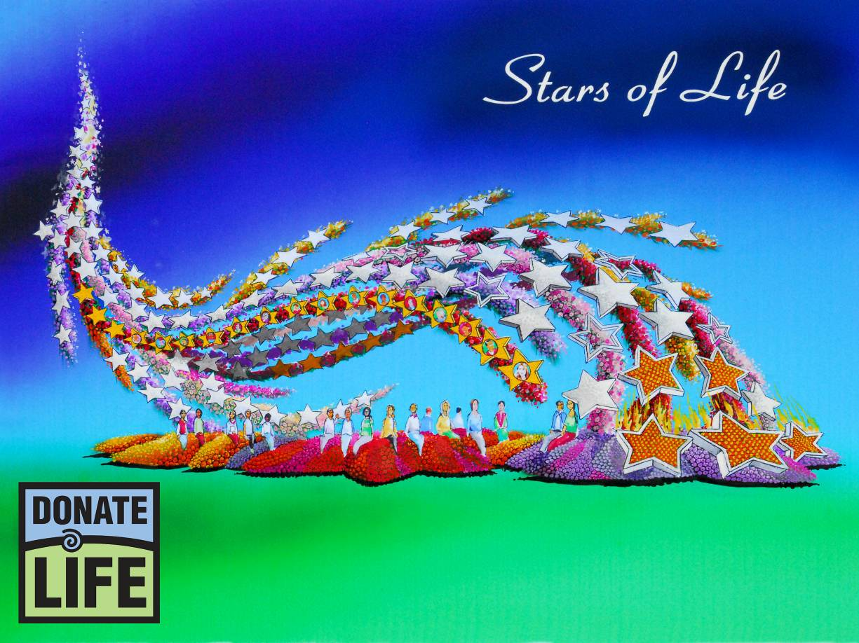

“Stars of Life”

Donors and recipients of organs, eyes, tissue and blood are “Stars of Life”, and our hats go off to the real-life stars who make organ, eye, tissue and blood donation an inspiring story of courage, compassion, hope and renewal. Donate Life’s sixth Rose Parade float entry features 24 float riders that include transplant recipients, living donors, and family members of deceased donors. The riders are immersed in a spectacular shower of stars climbing more than 30 feet in the air, representing all the people who make the gift of life possible.
Among the “Stars of Life” are 30 gold stars with floragraphs – artistic portraits created with floral materials – depicting loved ones whose donations of organs, corneas and/or tissue saved and healed those in need. White stars represent those among us who have been touched by donation, while transparent stars symbolize those in need of donated organs, corneas and tissue. The large orange-yellow stars at the front of the float carry more than 1,000 dedicated roses, each carrying a personal message of love, gratitude and hope to a donor, recipient or candidate in need of a life-saving transplant.
Everyone can be a star and save lives by signing up to be an organ, eye and tissue donor on their state donor registry and by donating blood in their community.

Donate Life Rose Parade® Float
2009 Official Partners

Benefactors

Astellas Pharma US, Inc.*
American Association of Tissue Banks (AATB)*
Donate Life America
Family Circle Rose Dedication Program
OneLegacy*#
National Donor Memorial and UNOS

Float Rider Sponsors

AlloSource
Blood Bank of San Bernardino and Riverside Counties
California Transplant Donor Network
Cedars-Sinai Comprehensive Transplant Center
Center for Donation & Transplant
Donate Life California Organ & Tissue Donor Registry
Donate Life Indiana
Donor Alliance, Inc.
Donor Network of Arizona
Gift of Hope Organ & Tissue Donor Network
Loma Linda University Medical Ctr. Transplantation Institute
Musculoskeletal Transplant Foundation
RTI Donor Services
St. Joseph Hospital Kidney Transplant Program
Upstate New York Transplant Services
Vesta Therapeutics, Inc.

Floragraph Sponsors

CryoLife, Inc.
Finger Lakes Donor Recovery Network
Gift of Life Donor Program
Iowa Donor Network
Life Alliance Organ Recovery Agency
LifeBanc
LifeCell Corporation
Lifeline of Ohio
Lifesharing
LifeSource
Living Legacy Foundation
The Living Legacy Foundation of Maryland
Louisiana Organ Procurement Agency
Mid-America Transplant Services
Mid-South Transplant Foundation, Inc.
Midwest Transplant Network
NJ Sharing Network
UCLA Healthcare
Washington Regional Transplant Community

Contributing Partners

Association of Organ Procurement Organizations (AOPO)
Health Promotions Now
JDI Communications, Inc.
Phoenix Decorating Co.

as of 6/9/08
* includes float rider sponsorship
# includes floragraph sponsorship

