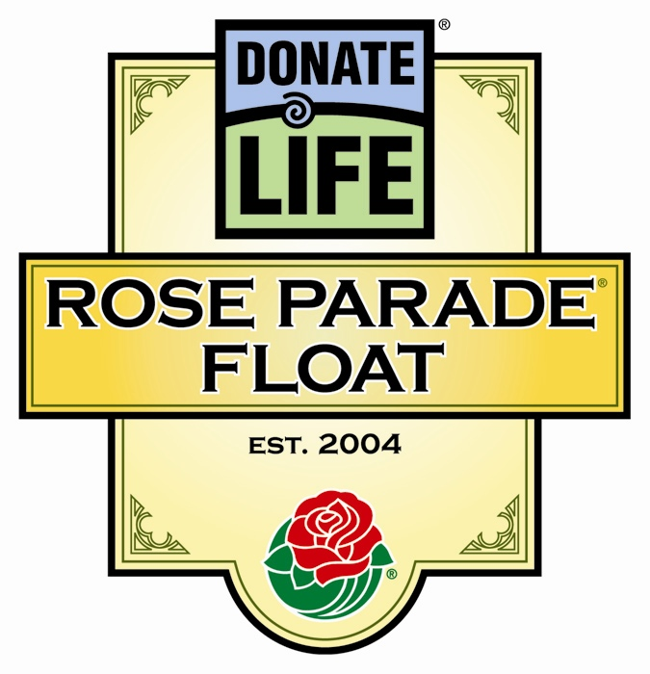

Media Contacts: JDI Communications, Inc., (213) 612-4927
Rivian Bell, (888) 477-4319 (24/7), rlb@abmac.com
Lisa Bernfeld, (310) 556-3227, lbernfeld@jdipr.com

THOUSAND-ROSE HEART TO BLOOM AT THE ROSE PARADE®
FOR THOSE TOUCHED BY ORGAN AND TISSUE DONATION

First ‘Family Circle Garden’ Pilgrims Travel Cross-Country to Dedicate Roses Dec. 30;
Touching Messages Convey the True Meaning of Donation

PASADENA, Calif., Dec. 26, 2006 – For four years, the Donate Life Rose Parade float has been a special way to inspire 30 million television viewers to save lives through organ and tissue donation. This year, the float will be led by an enormous heart of 1,000 roses from 50 states, with each rose dedicated to someone touched by donation.

This Family Circle Garden speaks to the emotions inherent in the 2007 Donate Life Rose Parade float, Giving From The Heart. Each rose is tagged with a personal message to those who gave, received, or await the gift of life, or contributed to the life-saving and life-enhancing donation process. For some, the symbolism is so profound that they have decided to travel from across the U.S. to personally place their roses in the garden. Some of these unusual “pilgrims to Pasadena” include:

- Joyce Silver (New York), whose son Paul required a kidney transplant as a result of the effects of Alports disease, will join daughter Sharon, who lives in Phoenix. After receiving the kidney he so desperately needed, Paul lived another 20 years before passing away from unrelated causes. Two of Sharon’s children also have Alports and will eventually need kidney transplants.

- Krisann McReynolds (Aurora, Colo.) will place a rose for her sister, Rebecca Drew, who became a tissue donor following her death last year from a sudden heart attack. “This is a tribute to her and to her life from me and her children. Rebecca’s three children made the decision to donate,” said Krisann.

- Eric Penn (San Jose, Calif.) is a kidney recipient who decorated the Donate Life float last year when he learned that the family of his kidney donor, Ricky Ward Moore, wanted to meet him. Penn will return this year along with several family members to his childhood hometown of Pasadena to decorate the float and to place a rose in the Family Circle Garden “to give thanks to Ricky.”

- MORE -
Donate Life Float Family Circle – 2-2-2

- Renee Rhodes and her six-year-old son, Taylor (Breaux Bridge, La.) will place four roses from family members in memory of her husband Travis, who died in a boating accident three years ago. Travis’ recipients benefited from his corneas, tendons, and other tissue. Renee will also place eight other roses dedicated by fellow Louisianians. One of the vials that Renee and Taylor will place will bear the message: “In memory of Justin Harrison - At the age of 15, Justin saved five lives through organ donation and gave sight to two. I miss you my son, my hero. You will forever be in my heart. Love, Mom” (Libbie, Lafayette, La.).

Touching tributes such as Libbie’s abound in the Family Circle Garden, such as one from Dave (Fullerton, Calif.), who wrote, “In memory of Lacey - I received the gift of your pancreas on February 12, 2006. I never knew you, but I will love you forever!” A dedication from Jerome (Kaukauna, Wis.) honors Bette Kroll: “You always wanted to go to the Rose Parade, now you are on the float. Your family & friends love and miss you.”

Another rose will be placed for a beloved grandson: “In memory of Andrew Spencer - We miss you so much and you're in our minds all the time. We are so proud that you were able to help someone have a better life. We love you. Grandma and Grandpa” (Clyde, Ontario, Calif).

More than 93,000 Americans currently await life-saving organ transplants, with 17 people dying each day due to the shortage of donated organs. Every year hundreds of thousands of people need donated tissue to prevent or cure blindness, heal burns or save limbs, and one out of three people will need donated blood in their lifetime.

The Donate Life float will carry 23 riders from the U.S. and Canada, all of whom are living donors or donor family members who contributed organs, tissue, or blood. The float’s theme, Giving From The Heart, brings to life the good nature of all organ, tissue and blood donors. Giving From The Heart is sponsored by a nationwide partnership of organizations united to inspire all people to donate life through organ, tissue and blood donation.

The 118th Rose Parade, themed Our Good Nature, will take place on Mon., Jan.1, 2007 at 8:00am PST. Additional information about the Donate Life float can be found at www.donatelifefloat.org.

# # #

