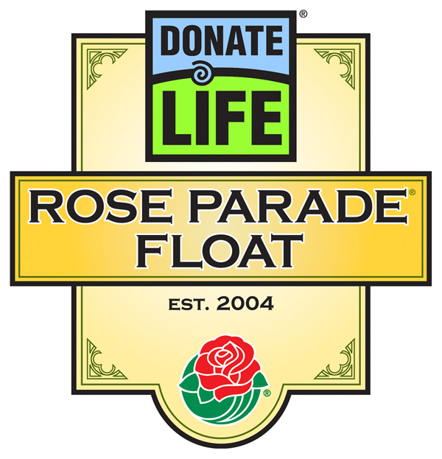
FOR IMMEDIATE RELEASE

Media Contacts: JDI Communications, Inc., (213) 612-4927
Rivian Bell, (888) 477-4319 (24/7), rlb@abmac.com
Lisa Bernfeld, (310) 556-3227, lbernfeld@jdipr.com

ORGAN, TISSUE AND BLOOD DONORS, RECIPIENTS
FROM ACROSS THE COUNTRY BRING INSPIRING STORIES TO
DONATE LIFE ROSE PARADE® FLOAT DECORATING

Weekend Decorating Starts Dec. 3 with California DMV and Bakersfield Volunteers

LOS ANGELES, Calif. Nov. 30, 2006 – Every Rose Parade float is assembled by volunteers who enjoy bringing the floats to life, but only one float attracts nearly 1,000 volunteers from across California and the U.S. with its mission to inspire people to donate life through organ, tissue and blood donation: the 2007 Donate Life Rose Parade Float, Giving from the Heart. Beginning Sun., Dec. 3, volunteers who vied for the opportunity to decorate this unique float will come together every weekend and throughout the last week of December to ensure that Giving from the Heart is ready to carry its precious human cargo – 23 riders from 11 states and Canada who are all living donors or donor family members.

The first day of decorating is especially meaningful this year because of participants from the California Department of Motor Vehicles (DMV), which has been instrumental in dramatically increasing the number of registered organ and tissue donors on California’s state-authorized donor registry through driver’s license and ID card applications. A DMV employee whose father was an organ and tissue donor will represent the organization on this year’s float for the first time.

One of the nearly 50 DMV decorators on Dec. 3 is Clorinda Reynoso, an examiner at the DMV Visalia DMV field office, who donated a kidney to her brother-in-law. “If it’s going to help someone, I’d do it again if I could, in a heartbeat,” she said recently. Other DMV volunteers will come from Canoga Park, Compton, El Segundo, Irvine, Lancaster, Rancho Cucamonga, Van Nuys, Whittier and Winnetka.

Joining the DMV volunteers on Dec. 3 will be nearly 40 Bakersfield residents who have been touched by organ and tissue donation, including Tricia Blodgett, former Miss Bakersfield. Blodgett emphasized organ and tissue donation during her reign, and she is now inspiring a new contestant for Miss Bakersfield to take on donation as her platform. Joining Blodgett will be donor wife Grace Obert, whose beloved husband Juergen passed away two years ago, and Becky Pitre, whose son is a liver recipient and whose daughter is now on the liver transplant waiting list.

Hundreds of Southland residents will continue weekend decorating through December. In the days before the parade, the 23 riders from North America will be on hand to put the final touches on the float with live flowers. A full list of decorating sessions and participants is attached.
- MORE -

Donate Life Rose Parade Decorating – 2-2-2

The 2007 Donate Life Rose Parade float marks the fourth appearance of the donation and transplant community in the Parade. Giving From The Heart is laden with symbolism: eight gift-wrapped presents represent the lives that can be saved by a single organ donor; 50 bouquets signify the lives that can be saved or enhanced by a single tissue donor; and the red ribbon’s three loops represent the lives that can be touched through a single blood donation. In addition, the tags adorning the presents are written in English, Spanish and Chinese. Also, more than 1,000 individually dedicated roses will be placed in the heart-shaped “Family Circle Garden” at the front of Giving From The Heart. And Donate Life will again salute the importance of the Hispanic community’s contribution to organ, tissue and blood donation by presenting the float’s logo both in English and in Spanish, “Done Vida.”

The 118th Rose Parade will take place on Monday, January 1, 2007 at 8:00 am PST featuring spirited marching bands from throughout the world, majestic floral floats and high-stepping equestrian units. Additional information is available at www.donatelifefloat.org.

# # #

All decorating will take place at the Rose Palace, Phoenix Decorating Co., 835 S. Raymond Ave., Pasadena, CA.

Date | Shift Time | Featured Group
Sun Dec 3 | 9am-5pm | California DMV & Bakersfield Community
Sat Dec 9 | 9am-5pm | Orange County Community and Lifesharing (San Diego)
Sat Dec 16 | 9am-5pm | Inland Empire Community, UOTA and NKF Team Southern California
Tue Dec 26 | 8am-3pm | OneLegacy Family Services (Donor Families)
Tue Dec 26 | 3pm-9pm | OneLegacy Family Services (Donor Families)
Wed Dec 27 | 8am-4pm | Loma Linda University Medical Center  Blood Bank of San Bernardino and Riverside Counties
Wed Dec 27 | 4pm-11pm | Asian Community
Thu Dec 28 | 8am-4pm | Cedars-Sinai Medical Center
Thu Dec 28 | 4pm-11pm | St. Joseph Hospital & CVS
Fri Dec 29 | 8am-4pm | OneLegacy Family Services (Donor Families)
Fri Dec 29 | 4pm-11pm | OneLegacy Family Services (Donor Families)
Sat Dec 30 | 8am-1pm | Float Rider Media Day
Sat Dec 30 | 1pm-8pm | Official Float Partners, TRIO Ventura County/West Valley
Sat Dec 30 | 8pm-11pm(?) | No group

